INTERNATIONAL BUSINESS PLAN EVENT
Eagle Nest Outfitters, Inc.
Costa Rica

ArdreyKell DECA Chapter
ArdreyKell High School
10220 ArdreyKell Road
Charlotte, North Carolina 28277

AnnaliseBoese
Vanessa Ye

February 2015

TABLE OF CONTENTS

- EXECUTIVE SUMMARY………………………………………………….………..1
- INTRODUCTION………………………………………………………………….…2
- ANALYSIS OF THE INTERNATIONAL BUSINESS SITUATION…….…………4
  - Economic, political and legal analysis of the trading country………….…………4
    - Describe the trading country’s economic system, economic information important to your proposed business/product/service, the level of foreign investment in that country.………………………………………………4
    - Describe the trading country’s governmental structure and stability, how the government controls trade and private business…………………….6
    - Describe laws and/or governmental agencies that affect your business/product/service [i.e., labor laws, trade laws (U.S.A. and/or Canada and foreign)] ……………………………………………………7
  - Trade area and cultural analysis…………………………………………………...8
    - Geographic and demographic information, important customs and traditions, other pertinent cultural information, competitive advantages and disadvantages of the proposed product and/or service ……………..8
    - Market segment analysis target market (age, income level, population estimate, other specific demographic and economic information)customer buying behavior related to the proposed product and or service………………………………………………………………….10
    - Analysis of the potential location—importance and requirements of each trade document required by the U.S.A. and/or Canada and the country of choice ………………………………………………………………….10

- PLANNED OPERATION OF THE PROPOSED BUSINESS/PRODUCT/SERVICE………………………………..…………..…….12
  - Proposed Organization…………………………………………………………...12
  - Proposed product/service………………………………………………………...15
    - Details of the product(s)/service(s) to be offered; include potential suppliers, manufacturing plans, inventory policies, if applicable. If the business is a service business, appropriate information about plans to provide the service, including necessary supplies.…………………….15
    - How the product/supplies will be transported to/from the home country; costs, benefits, risks of the transportation method; documents needed to transport the product/supplies …………………………………………17
  - Proposed strategies……………………………………………………………….19
    - Proposed pricing policies, what currency will be used, costs, markups, markdowns, relation to competition, factors that could affect the price of the product (e.g., competition, political conditions, taxes, tariffs, transportation costs) …………………………………………………...19
    - Proposed promotional program, promotional activity(ies), media availability, costs, one-year promotional plan outline ………………...20
- PLANNED FINANCING……………………………………………………………21
  - Projected income statements for first year’s operation (sales, expenses, profit/loss)……………………………………………………………………….21
  - Projected balance sheet for the end of the first year …………………………….21
  - A brief narrative description of the planned growth of the proposed business, including financial resources, needs and a brief three-year plan projection……..22
- BIBLIOGRAPHY……………………………………………………………………23
- APPENDIX…………………………………………………………………………..24

I. EXECUTIVE SUMMARY

Eagle Nest Outfitters, Inc. (ENO) is a privately owned company that features unique, practical, and portable nylon hammocks designed for any tropical expedition. The ENO hammock’s ability to fold into a compact and transportable case makes it the perfect hammock to bring on any adventure. ENO hammocks fit in any normal backpack and are simple to set up for effortless relaxation. Eagle Nest Outfitters, Inc. headquarters are currently located in Asheville, North Carolina and the brand is sold in over 750 retailers nationwide. In 2016, Eagle Nest Outfitters, Inc. plans to expand across international borders to the exotic country of Costa Rica.

Costa Rica, known for its abundant forests and national parks, is the perfect location for Eagle Nest Outfitters, Inc. to branch out. The country is a widely popular tourist destination due to its bountiful forests and beautiful beaches and relies heavily on tourism in their national economy. ENO products are specifically targeted at individuals who enjoy outdoor activities and hiking, but the versatile hammock can also be used for a variety of activities. Additionally, Costa Rica is a member of the Central American Free Trade Agreement. This reduces taxes and tariffs between Costa Rica and the United States, making it the perfect country to do business with. Central America’s close proximity to the United States also allows for quick and efficient distribution of the products. Eagle Nest Outfitters, Inc. will export shipments from the headquarters in Asheville, North Carolina to the San Jose, Costa Rica. From San Jose, the shipments will be distributed to the prospective outdoor shops that the products will be sold in.

In 2016, the Eagle Nest Outfitter hammocks will be sold in five stores throughout the country of Costa Rica. Although the company currently sells six types of hammocks and three types of suspension systems along with a range of other accessories, we have chosen to only offer the two most popular hammocks and suspension straps as well as select accessories within the first year of expansion to Costa Rica. In the first year, the Eagle Nest Outfitter hammocks will be sold in five sports and outdoor shops. These types of shops are very popular amongst tourists who are looking to engage in ecotourism and need to rent or buy equipment. These original five shops are Pura Vida Ride, Costa Rica Surf Club Surf Shop, Stone Mountain Outdoors, Outdoor Gear, and Uhuru Outdoors. These shops have all been highly rated on review sites such as tripadvisor, yelp, and other trusted websites. In our second year, we plan to expand to ten outdoor shops; the locations for these shops will be decided throughout the first year. By the third year, ENO hammocks will be sold in fifteen outdoor shops around the country of Costa Rica.

In Costa Rica, we will have 2 sales assistants in charge of collecting shipments from San Jose and distributing them to their proper locations. They will also be in charge of making sure that the shops are satisfied with products as well as promoting the products to prospective outdoor shops. In the third year, another sales assistant will be hired to help with the duties of managing distribution between the fifteen outdoor shops.

Overall, bringing Eagle Nest Outfitters Inc. to Costa Rica will be a worthwhile endeavor. Costa Rica is a country renowned for its abundant ecotourism and ENO hammocks are bound to be a popular product amongst adventurous travelers. This portable hammock allows travelers to enjoy relaxation at ease during a variety of endeavors available in Costa Rica.
II. INTRODUCTION
Eagle Nest Outfitters Inc. began as a small operation in Florida when brothers Peter and Paul Pinholster decided to begin a business that would challenge them creatively. They started their company in a minivan selling hammocks at music festivals and community gatherings. In time, the Pinholster brothers found themselves with more business than they could handle. They expanded their company and ENO (Eagle Nest Outfitters, Inc.) settled down in Asheville, North Carolina.
Today, Eagle Nest Outfitters, Inc. continues to supply high quality hammocks and accessories as a thriving company. These hammocks, more widely known as ENOs, range from 18 to 29 ounces and can hold up to 400 pounds of weight. They also span from 4.5 to 8.5 feet for a roomy and comfortable seat. ENO’s consolidate into small sack attached to the hammock and can easily fit into any backpack or beach bag. In our first year of selling products to retail stores in Costa Rica, we will offer the SingleNest and DoubleNest hammocks along with the SlapStrap Suspension System and the SlapStrapPRO.Suspension System. Hammock accessories such as the Underbelly Gear Sling and Guardian Bug Net may be offered depending on each outdoor shop. More products will be offered in future years as sales are projected to increase substantially each year.
There is nothing more relaxing than enjoying the view from the top of a mountain or the sandy seashore. The exuberant variety of flora and fauna in the wilderness and countless palm trees along the beaches of Costa Rica are perfect places to set up this comfortable hammock. Scenes such as this are what led to our desire to expand ENO operations into the Costa Rica marketplace. The prospective outdoor shops that will carry our products in 2016 are located in popular tourist destinations in Costa Rica such as Guanacaste, Tamarindo, and San Jose.
Positioned as a small country in Central America, Costa Rica is known for its lush forests and magnificent waves to surf. With 25% of the country made of up protected national parks and rainforests, which hold 6% of the world’s biodiversity, it is the perfect spot for taking canopy and zip-lining tours. Aside from the breathtaking rainforests, Costa Rica is home to over 1,000 miles of coastline filled with pristine beaches. Whether you are hiking through the deciduous jungles or lying by the crystal blue ocean, there is one product that would be an ideal asset to your vacation. Eagle Nest Outfitters, Inc. creates comfortable, portable hammocks that are both efficient and effortless to use.
Additionally, this country's strategic position in the center of the western hemisphere allows for easy facilitation of trade. The government's positive attitude towards foreign investment and access to international markets makes Costa Rica an ideal location to expand this business. Costa Rica’s economy is based heavily on tourism. Over one million tourists make the venture to this beautifully diverse country each year. The standard of living in Costa Rica is relatively high, and people living there can enjoy the same luxuries at a lower price. The United States is already the main trading partner with Costa Rica and it accounts for 70% of direct investments. Additionally the Central American Free Trade Agreement enables free trade policies between the two countries and catalyzes smooth and low costly trade.
Our target market consists of tourists, ages 20-40, who enjoy adventure and relaxation. The perfect retailers for ENO hammocks are stores specializing in tours and rentals for adventure sports. Pura Vida Ride, Costa Rica Surf Club Surf Shop, Stone Mountain Outdoors, Outdoor Gear, and Uhuru Outdoors are located in different destinations throughout Costa Rica. These stores either offer full service rental shops, sell outdoor sports gear, or both. A perfect addition to their product mixes would be the ENO portable hammocks. Guanacaste and Tamarindo, two locations of the prospective stores are two of the most popular tourist destinations in Costa Rica. The other three stores are located in San Jose, Costa Rica. Although San Jose is a modern city, it is the capital of the country and many tourists arrive in the city before departing to their vacation destinations. This makes San Jose a prime location for tourists to purchase necessary equipment before heading on their tropical adventures.
The official language in Costa Rica is Spanish, therefore posing a large obstacle for trade. Also, the seasons are opposite in Costa Rica and the United States. We will take this into consideration when planning for high sales from tourists. Additionally, we will utilize many Internet resources, such as CIA World Factbook and VisitCostaRica.com to help us gain more knowledge and information to promote the growth of ENO in Costa Rica.

III. ANALYSIS OF THE INTERNATIONAL BUSINESS SOLUTION
- Economic, political and legal analysis of the trading country
- Describe the trading country’s economic system, economic information important to your proposed business/product/service, the level of foreign investment in that country
According to the 2014 index of Economic Freedom, Costa Rica has the 53rd freest economy in the world and its economic freedom score is 66.9. Costa Rica has a free market economy with a good competitive level and advances and developments in infrastructure, technology, and macroeconomic stability. The current population of the country is 4,755,234 with 2.222 million in the labor force and the country’s gross domestic product per capita is $12,900.
Additionally Costa Rica exports approximately $11.66 billion annually. Main exports include bananas, pineapples, coffee, melons, ornamental plants, sugar, beef, seafood, electronic components, and medical equipment. Also, even though the country has not discovered sources of fossil fuels—apart from minor coal deposits, its mountainous terrain and abundant rainfall have permitted the construction of a dozen hydroelectric power plants, making it self-sufficient in all energy needs, except oil for transportation. Costa Rica exports electricity to Central America and has the potential to become a major electricity exporter if plans for new generating plants and a regional distribution grid are realized. Costa Rica’s reliable export revenue creates economic stability, making it a great country to establish or invest in a business in.
Foreign investors are highly attracted by the country's political stability and relatively high education levels, as well as the incentives offered in the free-trade zones. Costa Rica has attracted one of the highest levels of foreign direct investment per capita in Latin America, its stock of foreign investment is at $21,700,000,000, and the country is ranked #70 worldwide. FDI Intelligence, a publication by the Financial Times, named Costa Rica the "Best Country of the Future for Foreign Direct Investment in Central America and the Caribbean."

- Describe the trading country’s governmental structure and stability, how the government controls trade and private business
Costa Rica is a democratic republic with a very strong system of constitutional checks and balances. Executive responsibilities are vested in a president, who is the country's center of power. There also are two vice presidents and a 20-plus-member cabinet. The president and 57 Legislative Assembly deputies are elected for 4-year terms. Judicial power is exercised by the Supreme Court of Justice, which is composed of 22 magistrates selected for renewable 8-year terms by the Legislative Assembly, and subsidiary courts. The country's political system has steadily developed, maintaining democratic institutions and an orderly, constitutional scheme for government succession. Several factors have contributed to this trend, including enlightened leadership, comparative prosperity, flexible class lines, educational opportunities that have created a stable middle class, and high social indicators.
Costa Rica has long emphasized the development of democracy and respect for human rights. Also as an active member of the international community, Costa Rica proclaimed its permanent neutrality in 1993. Its record on the environment and human rights and advocacy of peaceful settlement of disputes give it a weight in world affairs far beyond its size.
The Costa Rican government is interested in attracting foreign direct investment in general, with a special focus on investments that enable Costa Rican exports and tourism. Tourism continues to bring in foreign exchange, as Costa Rica's impressive biodiversity makes it a key destination for ecotourism. Tourism overall in Central America has increased over 18% in the last 4 years, mainly due to increases in tourism to Costa Rica and Panama. Because of Costa Rica’s heavy reliance on tourism, our products have great potential sales because of the demand that will come from travelers.
However, bureaucracy and trouble with enforcing contracts are threats to business. Curbing inflation, reducing the deficit, and improving public sector efficiency through an anti-corruption drive, remain key challenges to the government. Previous political resistance to privatization had stalled liberalization efforts. However, after the signing of CAFTA, Costa Rica is now open to competition with its Central American partners in its insurance and telecommunications markets.
- Describe laws and/or governmental agencies that affect your business/product/service [i.e., labor laws, trade laws, (U.S.A. and/or Canada and foreign)]
Costa Rica joined other Central American countries, plus the Dominican Republic, in establishing a Trade and Investment Council with the United States in March 1998, which later became the Dominican Republic–Central America Free Trade Agreement. The countries involved in CAFTA-DR include Costa Rica, El Salvador, Guatemala, Honduras, Nicaragua, the Dominican Republic, and the United States. Signed in August of 2004, provisions of the agreement included eliminating tariffs, opening markets, reducing trade barriers, and promoting transparency. CAFTA-DR has facilitated trade and investment between these countries and has furthered regional development. The agreement has specifically benefitted Central America and the Dominican Republic by increasing the standard of living, stabilizing the economy, and increasing productivity. The United States has also benefitting through new business opportunities, a decrease of illegal immigration, as well as economic and political stability. The United States is currently Costa Rica’s main trading partner, accounting for about 47% of Costa Rica’s total imports.
- Trade area and cultural analysis
  - Geographic and demographic information, important customs and traditions, other pertinent cultural information, competitive advantages and disadvantages of the proposed product and/or service
Located in the heart of Central America, Costa Rica is a country filled with exuberant biodiversity and scenic waterfronts. Costa Rica has a varied topography with coastal plains that are separated by volcanic mountain ranges. There are 800 miles of coastline, both on the Atlantic and Pacific oceans and the palm trees are perfect for setting up your ENO. The coastal lowlands of Costa Rica are incredibly biodiverse and feature many different types of plants and wildlife. Both coasts feature mangrove swamps and the Gulf of Mexico side is heavily forested with tropical rainforests. Costa Rica also has several large national parks to protect its plethora of flora and fauna. Over 25% of Costa Rica’s national territory is dedicated to conservation with over 20 national parks, 8 biological reserves, animal refuges, and several protected areas. Some of these parks include the Corcovado National Park (home to large cats such as jaguars and smaller animals like Costa Rican monkeys), Tortuguero National Park and Monteverdo Cloud Forest Reserve. The climate of Costa Rica is tropical and has a wet season that lasts from May to November. Peak tourism months include January, February, June, July, November, and December.
Although our target market is the tourist population of Costa Rica, it is still important to acknowledge their cultural customs. An understanding of Costa Rican customs and etiquette will not only help you blend in, but will also help you adapt. It is common to say hello and goodbye to friends and acquaintances with a light kiss on the cheek – or an air kiss accompanied by a kissing sound. Costa Ricans are famous for observing Tico time, known locally as "la hora tica." Costa Ricans habitually arrive late, often by 30 minutes or more, to dinner, appointments, and get-togethers. Many Costa Ricans do not view late arrivals as rude – and their tardiness is not meant to offend – so it's best to adjust your expectations and tell your friends to arrive earlier than you'd like. Similarly, the word "ahora," which is Spanish for "now," means "later" or "tomorrow" in Costa Rica. If someone tells you they'll meet you "ahora" or are leaving "ahora mas tarde," it's best to clarify exactly when you'll see each other.
Costa Rica is a democratic republic and the country's political system has steadily developed, maintaining democratic institutions and an orderly, constitutional scheme for government succession. The Costa Rican government is interested in attracting foreign direct investment in general, with a special focus on investments that enable Costa Rican exports and tourism. Tourism continues to bring in foreign exchange, as Costa Rica's impressive biodiversity makes it a key destination for ecotourism. Tourism overall in Central America has increased over 18% in the last 4 years, mainly due to increases in tourism to Costa Rica and Panama. Costa Rica’s economy is heavily based on tourism and over one million tourists venture to this beautifully diverse country each year. Costa Rica is a country renowned for its abundant ecotourism and ENO hammocks are bound to be a popular product amongst adventurous travelers.
  - Market segment analysis target market (age, income level, population estimate, other specific demographic and economic information) customer buying behavior related to the proposed product and or service
People from all over the world visit Costa Rica to view the diverse wildlife and experience ecotourism. Our target market consists of tourists, ages 20-40, who enjoy adventure and relaxation. Since our product is not expensive, people of any economic level should be able to afford the ENO. Costa Rica attracts tourists from all over the globe and our product is perfect for any of these tourists. The Eagle Nest Outfitter hammock is easy to operate, portable, and small so that tourists will be able to easily bring home their new purchase after their vacation. Since our product can be set up almost anywhere, people will be drawn to purchase it. Not only is our product the perfect accessory to have during travels in Costa Rica, it is also functional in daily life.
  - Analysis of the potential location—importance and requirements of each trade document required by the U.S.A. and/or Canada and the country of choice
In the first year of international expansion to Costa Rica, Eagle Nest Outfitters, Inc. will be selling products to five different outdoor shops. The five stores that have been selected are Pura Vida Ride, Costa Rica Surf Club Surf Shop, Stone Mountain Outdoors, Outdoor Gear, and Uhuru Outdoors. The details for each prospective location are explained below.
Pura Vida Ride, a store specializing in tours and rentals for adventure sports. Pura Vida Ride has several locations scattered across Costa Rica and offers a full service rental shop for standup paddleboards, kayaks, mountain bikes, snorkel gear, volleyball, bocce ball, and body boards. A perfect addition to their product mix would be the portable hammocks. Guanacaste, one of the most popular provinces in Costa Rica, has several volcanoes, mountain ranges, and shorelines. The Pura Vida Ride location in Guanacaste, Costa Rica is the ideal site to begin international distribution of Eagle Nest Outfitters Inc.
Costa Rica Surf Club Surf Shop is based in Tamarindo Beach and provides surfing services such a surfboard rentals, surf school, surf trips, surf camp packages and on site ding repair. Committed to providing high-end equipment, open surf lesson schedules and affordable surf tours.
Stone Mountain Outdoors is stocked to support several outdoor pursuits. Whether travelers enjoy fishing, kayaking, camping and hiking, or all of the above, they have the essential gear, accessories, and clothing needed to make the most of travelers’ time outdoors.
Outdoor Gear offers a variety of different quality outdoor gear brands for purchase as well as several rental services for products such as kayaks.
Uhuru Outdoors offers some of the best outdoor brands in the world are found here. Products such as Patagonia, LaSportiva, Petzl, TrangoWorld, rock climbing books, and coffee are all offered in a great atmosphere.

IV. PLANNED OPERATION OF THE PROPOSED BUSINESS/PRODUCT/SERVICE
- Proposed organization
When bringing Eagle Nest Outfitters to Costa Rica, we will be looking for four different types of employees. Some of these employees with live in Costa Rica to distribute and keep in touch with the outdoor adventure equipment shops that will carry our product. Since we will not be in Costa Rica ourselves, we will need trustworthy and dependable employees to direct the distribution and bring in our shipments of ENO hammocks to the retail stores. Additionally, we are looking for employees interested in and familiar with ecotourism to help promote our product during meetings and to stay connected with our customers and each of the five outdoor gear retail stores. These jobs will be year round since ecotourism is prominent during all seasons in Costa Rica. They will be responsible of tasks such as keeping track of inventory, sales, stocks, and marketing information management.
Decisions will be centralized to maintain order and a bureaucratic system will the established in the workplace to facilitate efficient decision-making. Figure 1 displays a flowchart of the bureaucracy that will be utilized by with the future job positions in Costa Rica.

Figure 1:

Figure 2 displays proposed job descriptions for when Eagle Nest Outfitters expands to Costa Rica.
Figure 2:
Job position | Potential Number (Year 1) | Description
Owner/Founder at ENO | 2 | Brothers Peter and Paul Pinholster founded ENO in the summer of 1999 and have successfully grown the company over the past 16 years.
General Manager at ENO | 1 | Lane Nakaji is currently the general manager at ENO and overlooks operations, manages staff, and establishes business objectives.
General Manager at ENO in Costa Rica | 1 | One general manager will be hired in 2016 to overlook and direct all business operations between the United States and Costa Rica. The manager will be in charge of keeping track of inventory and making sure that shipments are exported in a timely fashion. He/she will also have the duty of overseeing the work of the sale assistants in Costa Rica.
Sales Assistants in Costa Rica | 2 | Two sale assistants will be hired to reside and work in Costa Rica with the expansion of ENO to this foreign country. They will be in charge of picking up shipments from San Jose, Costa Rica and distributing the shipments to the respective retail stores. These employees should be knowledgeable on our products, have good interaction skills, and problem solving skills.
Eagle Nest Outfitters, Inc. will use an area/geographic structure when expanding to Costa Rica. Since it is the first time that Eagle Nest Outfitters has done international business, it is important for the company to emphasize geographically specific strategies and focus decision-making on local needs in Costa Rica. The geographic structure will best allow us to understand conditions in Costa Rica and formulate strategies that will effectively meet the needs of the local business environment.
Our method of expansion is foreign direct investment. Eagle Nest Outfitters, Inc. is a relatively new and prospering business in the United States and expanding the company internationally will have great benefits. Although the company has only been around for 16 years, its products are already sold in over 750 specialty outdoors, backpacking, and winter sports retailer, premium-sporting goods retailers, and major outdoor specialty retail chains, as well as online. The wide popularity of the product in the United States foreshadows satisfactory sales revenues within the first three years of expanding to Costa Rica.
B. Proposed product/service
  - Details of the product(s)/service(s) to be offered; include potential suppliers, manufacturing plans, inventory policies, if applicable. If the business is a service business, appropriate information about plans to provide the service, including necessary supplies
In the first year of bringing Eagle Nest Outfitters to Costa Rica, we will be offering only our most popular items. We will be selling the two most popular hammocks, the DoubleNest Hammock and the SingleNest Hammock, the SlapStrap Suspension System and the SlapStrapPRO Suspension System, as well as select accessories. More products will be offered with each year of the expanding business. Both the SingleNest and DoubleNest hammocks fold into small compression sacks for easy convenience and transportation. They are simple to take anywhere and can be set up in seconds, and only weigh a total of 16 ounces and 20 ounces, respectively. Both hammocks are made from breathable, quick drying nylon and are able to support up to 400 pounds. The hammocks are also made with heavy-duty triple stitched seams for secure durability.
The hammocks will be exported from the inventory warehouse in Asheville, North Carolina and flown to San Jose, Costa Rica. Sale assistants will be responsible for picking up the shipments and taking them to the outdoor sporting good stores.
With Eagle Nest Outfitter, Inc. hammocks, we are aiming to provide customers with the highest quality relaxation products. ENO hammocks are the ideal product for adventure travelers and outdoor lovers and Costa Rica is their perfect destination. ENO hammocks are a one of a kind portable parachute hammock that has qualities found in no other products. Therefore, we plan to keep our products exactly the same since there is no other competitor currently on the market.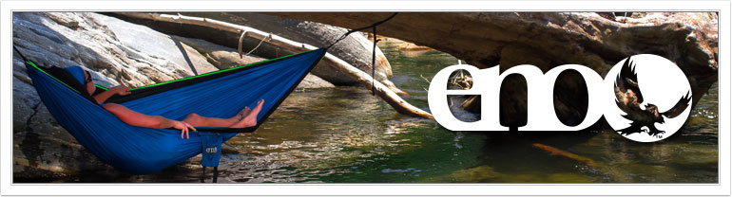
  - How the product/supplies will be transported to/from the home country; costs, benefits, risks of the transportation method; documents needed to transport the product/supplies
We have chosen to export our products from Asheville, North Carolina to San Jose, Costa Rica for several reasons. Our method of international shipping is reliable, simple, and cost efficient. By shipping our products, it is reassured that our shipments will arrive in San Jose and the method is also one of the most affordable international distribution routes. Proper documentation needed for international shipping include a commercial invoice, export packing list, pro forma invoice, certificate of origin, and shipper’s export declaration. These documents will assure that our shipments arrive efficiently in San Jose, Costa Rica. Once shipments have arrived, our sales assistants are responsible for collecting the shipments and distributing them to the five outdoor gear shops that Eagle Nest Outfitters, Inc. is selling to. Figure 3 exhibits the five shops as well as their locations and products/services offered at the shops.
Figure 3
Retail Store | Location | Products/Services offered
Pura Vida Ride | Las Catalinas at Playa Danta‬, Las Catalinas 50304‬, Costa Rica‬‬‬‬ | Full service rental shop for standup paddleboards, kayaks, mountain bikes, snorkel gear, volleyball, bocce ball, and body boards. Pura Vida Ride is located in Guanacaste, a popular tourist destination, surrounded by several volcanoes, mountain ranges, and shorelines.
Costa Rica Surf Club Surf Shop | Main street, Sunrise Mall shop #8, 152, Tamarindo 50309, Costa Rica | Costa Rica Surf Club Surf Shop based in Tamarindo Beach provides surfing services such a surfboard rentals, surf school, surf trips, surf camp packages and on site ding repair. Committed to providing high-end equipment, open surf lesson schedules and affordable surf tours.
Stone Mountain Outdoors | Santa Ana, Costa Rica | Stocked to support several outdoor pursuits. Whether you enjoy fishing, kayaking, camping and hiking, or all of the above, they have the essential gear, accessories, and clothing you need to make the most of your time outdoors.
Outdoor Gear | Frente a Pops Curridabat, Carretera Interamericana, Costa Rica | Offers a variety of different quality outdoor gear brands for purchase as well as several rental services for products such as kayaks.
Uhuru Outdoors  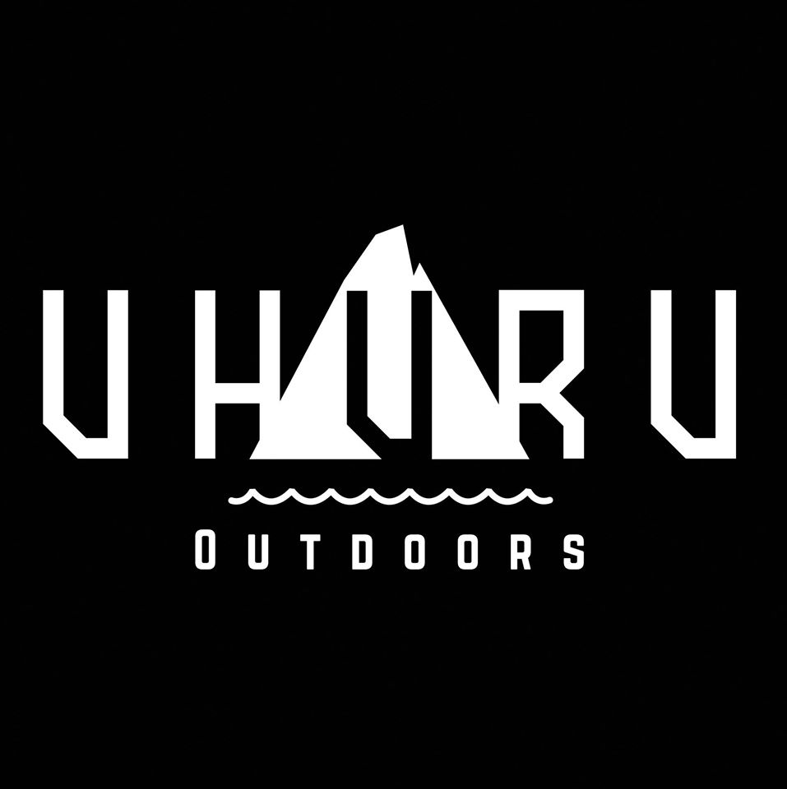 | Calle Convento, San Rafael de Escazu, Costa Rica | Some of the best outdoor brands in the world are found here. Apparel, Patagonia, LaSportiva, Petzl, TrangoWorld, rock climbing books, coffee, great atmosphere, amazing project.

- Proposed strategies
- Proposed pricing policies, what currency will be used, costs, markups, markdowns, relation to competition, factors that could affect the price of the product (e.g., competition, political conditions, taxes, tariffs, transportation costs)
Since we are exporting to retail stores in Costa Rica, we will be selling our products at a wholesale value, which allows the shops themselves to mark up the products to make a profit. However, we will still need to mark up our retail value by 30% due to the expenses of the international business plan. SingleNest hammocks will be sold for $29.95 USD and DoubleNest hammocks for $35.95 USD. This translation of prices from USD to Costa Rican Colon (CRC) is explained in Figure 4
Figure 4:
Product | Whole price in USD ($1) | Wholesale price in CRC (536.97 ₡)
SingleNest Hammock | $29.95 | 16082.25 ₡
DoubleNest Hammock | $35.95 | 19304.07 ₡
SlapStrap Suspension System | $9.95 | 5342.85 ₡
SlapStrapPRO Suspension System | $12.95 | 6953.76 ₡

2. Proposed promotional program, promotional activity(ies), media availability, costs, one-year promotional plan outline
The ENO is a portable hammock that consolidates into a small sack. It can fit easily into any backpack and for effortless travel. These hammocks range from 18 to 29 ounces and can support up to 400 pounds of weight. The ENO allows eco-tourists to hike and travel around the verdant country of Costa Rica effortlessly. Due to high demand in the United States, it is predicted that the ENO hammocks will have substantial sales in Costa Rica. Eagle Nest Outfitters, Inc. products are currently sold in over 750 retail stores nationwide in the United States. We have only proposed to sell our product to five retail stores within our first year of international expansion but exponential growth is predicted. We will have more sales during the peak months of tourism in Costa Rica (January, February, June, July, November, and December) since there will be more demand, but will still make considerable profit during the remaining months.
Since we are selling to retail shops, our products are offered at a wholesale price and therefore are relatively inexpensive. The shops will be able to mark up the prices and make a profit from the products. Through popularity amongst tourists, more retail stores will be drawn to our company and will desire to carry our products in their stores.
During the first year of sales, our sales assistants will be responsible of locating the next five locations that Eagle Nest Outfitters will expand to in our second year. Through experience in the country, our sales assistants will have adequate knowledge of the tourist destinations and shop popularity in order to make intelligent choices of which shops we will expand to. They will also be responsible for reaching out to the prospective outdoor gear retail stores and promoting our product to them.
V. PLANNED FINANCING
- Projected income and expenses
Refer to page 24. Peak months of tourism in Costa are January, February, June, July, November, and December and therefore revenue during those months will be slightly higher than normal months. Our peak season sales have been predicted to end up at approximately $29,488.55 and $21,075.75 during normal season sales. We have calculated all our costs and profits in US Dollars instead of Costa Rican Colon because this international business plan is aimed to profit the Eagle Nest Outfitters, Inc. establishment in the United States. All profits have been multiplied by five in order to accommodate the fact that we are selling our products in five different shops. We plan to give each sales assistant an annual salary of $40,000. In addition to costs such as utilities, supplies, and others, our total expenses total to $120,680.04 after the first year. After calculation of profit, our net operating income totals out to be $182,705.76. The ending cash balance once business taxes and investments are factored in is estimated to be $177,888.80.
- Projected balance sheet for the end of the first year
Refer to page 25 for the projected balance sheet for the end of the first year.

- A brief narrative description of the planned growth of the proposed business, including financial resources, needs and a brief three-year plan projection.
Eagle Nest Outfitters, Inc. will start out with a beginning cash balance of $50,000. In the first year, we will have our products in five locations around Costa Rica and plan to expand to ten in the second year and fifteen in the third year. Our revenue will therefore at least triple by the third year. Additionally, we will be offering more products throughout the years, which will also increase sales.
VI. BIBLIOGRAPHY
http://www.xe.com/currencyconverter/convert/?Amount=1&From=USD&To=CRC
http://www.linkedin.com/company/eagles-nest-outfitters-inc
http://www.costaricasurfclub.com
http://www.eaglesnestoutfittersinc.com/category/ACCESSORIES.html
https://www.google.com/maps/

VII. Appendix

