SCRUB DADDY

Tangible factors: yellow, smiley face, rough texture, bright hue
Intangible factors: warranty, delivery

To go to Malaysia, we are going to ADAPT our current product to fit the new market
we are choosing this technique because in Malaysia, the selling of yellow clothing is illegal so this sentiment of dislike will probably be carried on to other products and parts of life. Therefore, we will need to change the color of the scrub daddy to a neutral orange.

Product Positioning
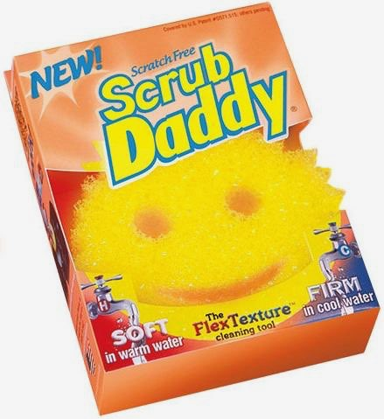
we are going to position our product by billboards targeting women and placing advertisements during soap operas. Our competition our other things that use scrubs to clean, which is direct competition. The attributes of Scrub Daddy is an orange scrub with a 5 inch diameter. The price will line up with competitor prices and the quality is higher than other scrubs are direct competitors.

Grey Market
Scrub Mommy
The quality decreases so that the orange color fades away faster and doesn't have the strength that the Scrub Daddy has.
The price would reduce dramatically from $15 USD to $2 USD
Target Market: Moms
Competition: Scrub Free
Price: $2
Product Package
Family Brand: Scrub Daddy
sells: soap Scrub-dub-dub

