Table of Contents
I. EXECUTIVE SUMMARY 1
II. INTRODUCTION 2
A. description of the business or organization 2
B. description of the community 3
C. description of the business/organization’s missions, target market, existing branding efforts 4
III. RESEARCH METHODS USED IN STUDY 5
A. description and rationale of research methods selected 5
B. process used to collect the selected research methods 6
IV. FINDINGS AND CONCLUSIONS OF THE STUDY 8
A. findings of the research study 8
B. conclusions based on the findings 11
V. PROPOSED REBRANDING PLAN 12
A. objectives and rationale of the proposed rebranding plan 12
B. proposed activities and timelines 15
VI. proposed budget 20
A. costs associated with proposed rebranding strategies 20
B. proposed metrics to measure return on investment (ROI) 23
VII. bibliography 28

I. EXECUTIVE SUMMARY
The Washington Redskins are a professional football team in the National Football League playing out of Washington, DC. They have been very successful in the past few seasons and are currently the third highest valued team in the league. However, as of recently the organization’s brand has come under heavy scrutiny from interest groups and public figures, even including President Obama. The term ‘Redskin’ is widely considered by the Native American community as a racial epithet that is extremely derogatory and offensive, and many call for the name to be completely changed. For this reason, the Washington Redskins will be rebranded as the “Washington Warriors.” Initial secondary research was conducted to learn more about the uproar caused by the Redskins current image, and to further justify a rebranding. In addition, primary research was conducted via an online survey to gather the opinions of fans regarding the project. Research concluded that many agreed that the current image could be deemed offensive, but if the team were to rebrand, they would have to retain some of the same elements as their former image. Taking all of this into account, the new Warriors look and feel still loosely resembles that of the Redskins, not drastically departing from their former look. To conduct the rebranding process, the organization will announce the rebranding via the team website and DC Metro advertisements. During the summer, the team will release the logo, name, and uniform on various spaced out dates, and eventually end with an intensive social media campaign. The total cost of the project is projected to be near $14 million, and is expected to produce, in addition to a controversy-free brand image, a significant sales and revenue increase.
II. INTRODUCTION
A. Description of the Business or Organization
The Washington Redskins are a professional football team based out of Washington, D.C, a large urban area that serves as the capital of the United States. The team currently belongs to the NFC Conference in the National Football League (NFL), and more specifically plays in the NFC East alongside the Dallas Cowboys, New York Giants, and Philadelphia Eagles. The team's stadium is FedEx Field located in Landover, Maryland, right outside of Washington, D.C, and is connected to the urban area via the D.C. public transportation system, the Metro. The Redskins have played 1,000+ games since 1932, which was the initial establishment of the team, and are one of the longest NFL organizations to have played. The Redskins have won five total NFL Championships (3 of which were Super Bowls) throughout their existence, and have a very storied history amongst fans all over the world. The organization has additionally won numerous division and conference titles, and is typically a top contender in the NFL year after year. According to Forbes.com ratings of the most valuable NFL franchises, Washington sits at 3rd with a total valuation of slightly over $1 billion. For 9 consecutive years now, and as recently as 2013 reported figures, the Redskins have broken the NFL single-season attendance record. They are a very popular team not only in the Washington, D.C. region, but also all over the world due to their historical success and popularity. The team has recently somewhat increased their fanbase with the drafting of Robert Griffin III and their successful 2012 season. Their current owner is multi-billionaire entrepreneur Dan Snyder.
B. Description of the Community
With its impressive monuments and museums, its stately government buildings and mansions, Washington D.C. is easily recognizable as the United State's capital city. The city is mainly based on government and everything from museums to mansions bring millions of tourists each year. Washington D.C. is the second most visited city in the United States (after New York) and is among the top travel destinations in the world.
The demographics of Washington, D.C. reflect an ethnically diverse, cosmopolitan, mid-size capital city. In 2010 the District had a population of 601,723 people. In 2011 Washington’s black population slipped below 50 percent for the first time in over 50 years. The city was, and has been, a majority-black city from the late 20th century through today.
Washington D.C. has a growing, diversified economy with an increasing percentage of professional and business service jobs. The gross state product of the District in 2010 was $103.3 billion. The gross product of the Washington Metropolitan Area was $425 billion in 2010, making it the fourth-largest metropolitan economy in the United States. As of June 2011, the Washington Metropolitan Area had an unemployment rate of 6.2%; the second lowest rate among the 49 largest metro areas in the nation.

C. Description of the Business/Organization’s Missions, Target Market, Existing Branding Efforts
The Redskins current target market is located in the DC Metropolitan area. This includes the actual District of Columbia, as well as vast surrounding areas in Virginia and Maryland that commute to DC daily via the Metro system. They also appeal generally appeal to young to middle-aged males who are typically fans of at least some type of sport.
Their current branding efforts are currently on par with essentially every other team in the NFL at this time, as there is no sight on their part that an intensive change needs to be made.
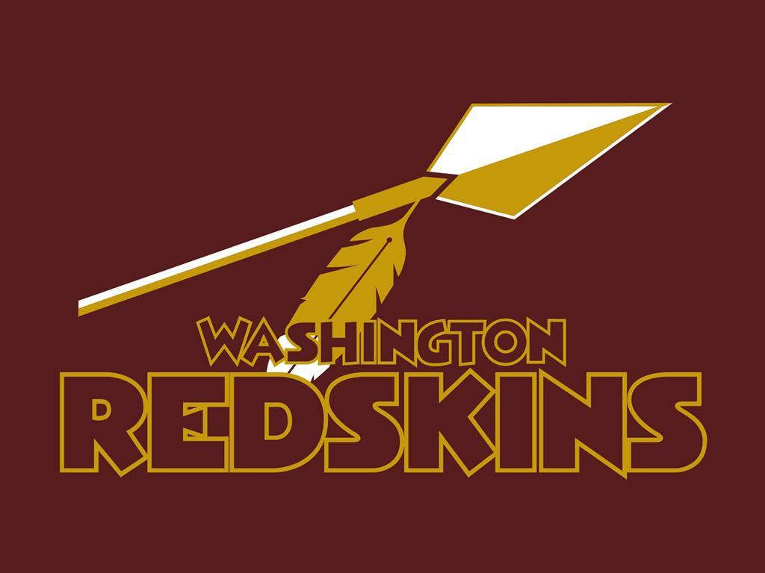
The organization does not officially have a mission statement.

III. RESEARCH METHODS USED IN STUDY
A. Description and Rationale of Research Methodologies Selected To Conduct the Research Study
The National Football League has one of the biggest followings in the sports and entertainment industry. Fans from all over the world follow the sport, from London to Washington, DC. So, when a change as major as a full rebranding of a team is being made, many fans will notice and react. Thus, it is imperative to gauge fan interest and opinions regarding the rebranding of the Washington Redskins before any official move is made. For our research, my partner and I first searched online secondary sources to identify why a rebranding is necessary and to justify this project, while later conducting intensive primary research to seek fan ideas and opinions regarding the specifics of the rebranding to occur.
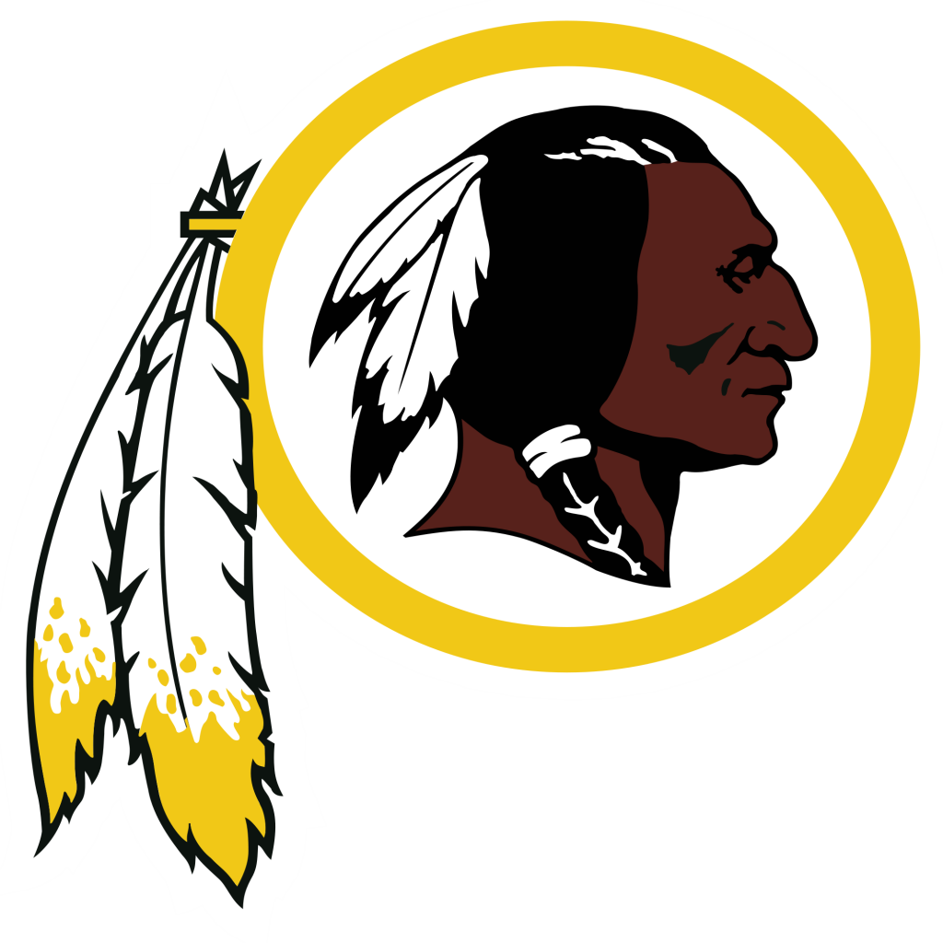
To start off, we must answer the question as to why we are rebranding. The Washington Redskins are currently the 3rd most valuable NFL team revenue-wise, and have renewed hopes of success after their drafting of Robert Griffin III and a successful 2012 season. So, why change? To start to answer this question and begin addressing the current problem at hand with the Redskins organization, my partner and I researched numerous secondary sources, mainly online articles from reputable news sites, which documented a recent controversy surrounding the team. My partner and I had noticed earlier in the year recent stories breaking on major news sites about a potential Redskins rebranding due to this issue, which lead us to even begin to contemplate this rebranding project. We used these online articles to further our understanding of the fundamental problems of the current Redskins brand and to justify this rebranding project. These online sources also provided an easy way to quickly find out the data we needed in this case. The specifics of the controversy written about will be discussed in Section IV of this paper.
In addition to the secondary sources my partner and I identified, we also wanted to gain direct NFL fan reaction on both the viability of a name/brand change for the Redskins organization, and the popularity of potential new brand images. To do this, we set up an online poll to be answered from users of www.reddit.com/r/nfl. This is a very popular website forum where NFL fans can discuss current happenings in the league, and share their opinions on a variety of football topics. We chose this website to aim directly at the people who would care the most about this rebranding; the fans. This website also allowed us to reach a large survey market simultaneously, without having to manually attempt to question fans in person via alternative survey methods. Since the online survey was aimed at only one group (NFL fans), there was little stratification of our sampling. We initially held concerns about there being a lack of variety in the answers due to a voluntary response bias, but ended up with over 65 responses from a wide range of unique users on this website, creating a diverse and representative sample group.
B. Process Used to Conduct the Selected Research Methods
To begin this section, we will discuss the specifics of our primary research, which we used as the basis for the actual rebranding. We first submitted a post asking for help on a school research project on the previously mentioned web forum, reddit.com/r/nfl, and set up a Google Docs Form in which users willing to help could answer a set of 10 questions. This was set up December 15th. Over the course of 2 weeks, we were able to track live responses to our online survey and gain an accurate representation of fan opinions regarding the rebranding. The questions we used are listed below.
- Would you support a rebranding of the Washington Redskins organization?
- Do you think that the current Redskins Brand image could be perceived as racist and derogatory towards Native Americans?
- Do you support President Obama’s recent decision to speak out in favor of a Redskins rebranding?
- If the Redskins were to rebrand, should they keep the same colors (maroon and yellow) as before?
- If you answered no to the previous question, what color scheme should be used if a rebrand were to occur? (Open ended question)
- If the Redskins were to rebrand, should they generally keep the same uniform design as currently used?
- If the Redskins were to rebrand, what should their new team name be? (Open ended question)
- Should the Redskins rebranding have a more patriotic new look due to the team’s location in Washington, DC?
- Should the Redskins organization, if to rebrand, open up new logo/name options to an online fan vote?
- Should the Redskins organization, if to rebrand, open up new uniform/helmet designs open to an online fan vote?
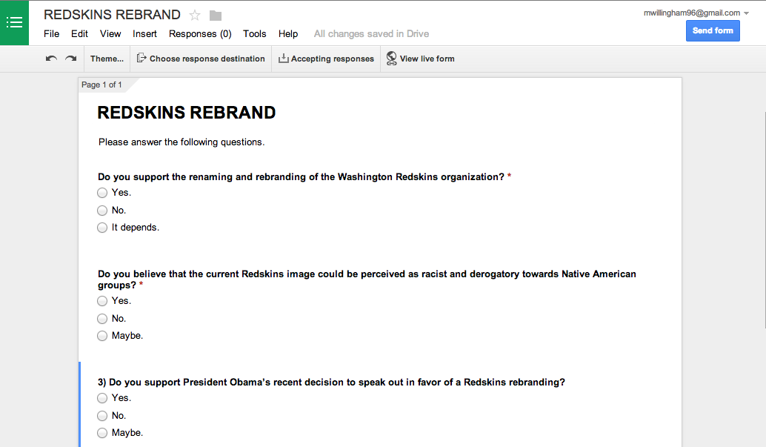
*A picture of the Google Poll we used is displayed below for reference as to how it appeared to the user in Figure 3B.1*
Figure 3B.1
To conduct our secondary online research, we searched both “Redskins rebranding” and “Redskins name controversy” on Google, and filtered it to only news posts that were published within the last 6 months. This led us to articles written on the National Review, the Washington Post, USA Today, BusinessWeek, and the Chicago Tribune that answered our questions and further justified the rebranding.
IV. FINDINGS AND CONCLUSIONS OF THE STUDY
A. Findings of the Research Study
We will start off this section by discussing the findings of our secondary research, which focuses on why this project is occurring. The articles all reiterated the same basic fact; the Redskins current name is stirring up controversy. Numerous Native American groups have recently spoken up against the team’s brand, saying that the term ‘Redskin’ is an offensive racial epithet, much like the “n” word in current American culture. In addition to the numerous Native groups, several other civil liberty groups have spoken out against the derogatory nature of the Redskins name, such as the NAACP and the ACLU. The outcry against the Redskins brand culminated with a statement by President Barack Obama denouncing the name and urging for a rebranding effort to take place immediately.
Shifting the focus to our primary research, this survey dealt with fan opinions regarding the rebranding, and potential ideas for rebranding activities to occur. The results of each individual question of our online survey are listed below. The survey resulted with 68 responses, so percentages are given out of that total number for each question.
- Would you support a rebranding of the Washington Redskins organization?
39.7% yes, 32.4% no, 27.9% maybe
- Do you think that the current Redskins brand image could be perceived as racist and derogatory towards Native Americans?
47.1% yes, 25% no, 27.9% maybe
- Do you support President Obama’s recent decision to speak out in favor of a Redskins rebranding?
38.2% yes, 61.8% no
- If the Redskins were to rebrand, should they keep the same colors (maroon and yellow) as before?
63.2% yes, 36.8% no
- If you answered no to the previous question, what color scheme should be used if a rebrand were to occur?
Open ended question; many of the color schemes users provided were Navy, Red, and Silver. Two users voted on a Black and Silver scheme, while another two voted on a Black and Gold scheme.
- If the Redskins were to rebrand, should they generally keep the same uniform design as currently used?
30.9% yes, 69.1% no
- If the Redskins were to rebrand, what should their new team name be?
Open ended question; the ‘Warriors’ response was surprisingly given by around 30% of users and was the most popular. The ‘Renegades’ response was the only other response given by more than 6 users.
- Should the Redskins rebranding have a more patriotic new look due to the team’s location in Washington, DC?
36.8% yes, 63.2% no
- Should the Redskins organization, if to rebrand, open up new logo/name options to an online fan vote?
75% yes, 25% no
- Should the Redskins organization, if to rebrand, open up new uniform/helmet designs open to an online fan vote?
85.3% yes, 14.7% no
B. Conclusions Based On the Findings
Starting off on the basis of why this rebranding is occurring, the racial controversy that the ‘Redskins’ name creates; we decided that a rebrand is immediately necessary with this organization. When a brand image is being promoted and sold today that offends any one large group of Americans, it is imperative that it be modified. We further justified our rebranding when someone as notable as the President of the United States came out and spoke regarding the subject, urging for a renaming. After observing the sheer amount of outcry against the current image of the Redskins, we decided that we must go forth with this project.
From the primary research my partner and I gathered, which focuses on the specifics of the rebranding process, we came to a few main conclusions that we would implement. Although fans were somewhat split over the prospect of a Redskins rebrand, they did generally agree that the name could be perceived as offensive to Native Americans. This is reason alone to begin a rebranding. However, due to the long history of the Redskins, NFL fans generally wanted to keep at least the same color scheme so the team could remain somewhat recognizable. However, they did desire a new uniform change that would be left up to the fans to vote on. When it came to the new team name and logo, they also wanted that to be left up to a fan vote. User responses listed the ‘Warriors’ team name as by far the most popular choice amongst responding fans, which we believed was due to the strong image the Warrior portrays, and the fact that it does not stray too far from the current Redskins image. This led my partner and I to conclude a few main points to take place during our rebranding. We decided to rename the organization as the Washington Warriors primarily due to the popularity of the name. Secondly, we chose a mascot and color scheme that did not stray too far from the current look of the team, so the history and feel of the Redskins would not be completely destroyed. Lastly, observing that fans wanted a say in this project, we decided to allow the fans to vote on a new alternate uniform for the Warriors.
V. PROPOSED REBRANDING PLAN
A. Objectives and Rationale of the Proposed Rebranding Plan
The rebranding effort will kick off with an intensive advertising campaign utilizing the DC Metro system. The Washington DC Metro system provides over one million rides per week to surrounding residents and commuters, so this will reach a large amount of the Redskins fan base in a short amount of time, and will get the initial word out about the rebranding. These ads will feature a QR-code linking to a countdown website, which will display the date of the announcement the new team name and logo. This website will serve to both inform NFL fans about the rebranding, and create publicity for the upcoming release.
Shortly following the NFL Draft and the ad campaign, when fans are becoming excited once more about the upcoming season, the new “Washington Warriors” team name and logo will be announced via the team website and a press release. This will serve to get word out about the rebranding at a time when many fans are interested in NFL happenings again, and once more create publicity for the new-look Washington Warriors. At this time, the team website, app, and social media accounts will be modified to reflect the new logo and name as well. This further goes to prepare fans for the new season of the Washington Warriors and establish the new look.
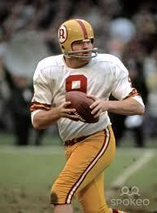
After the initial release of the updated name and logo, the organization will release the looks and design of the new Washington Warriors uniforms. The organization will receive newly designed uniforms from Nike (the official uniform provider of the NFL), and both upload them to the redesigned team website and hold a press conference modeling the new uniforms with current players. This action only serves to further the public awareness about the new-look Washington team. Additionally, the team will work with Nike to develop 3 “alternate” uniform concepts to be voted on by the fans. These jerseys will feature a “retro” Washington Redskins look, and will be worn only on select games. This allows the fans to have a say in the updating of their new team, as well as retain some of the old organization’s looks they have come to know and love. A potential alternate uniform choice depicting the 1970’s Redskins is pictured in Figure 5A.1.
Figure 5A.1
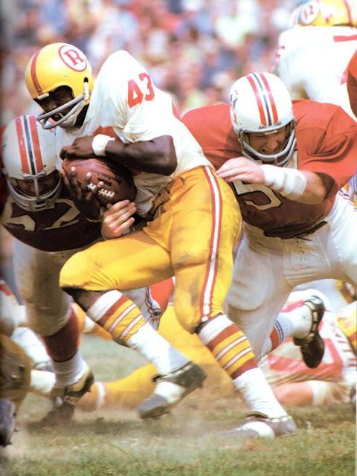
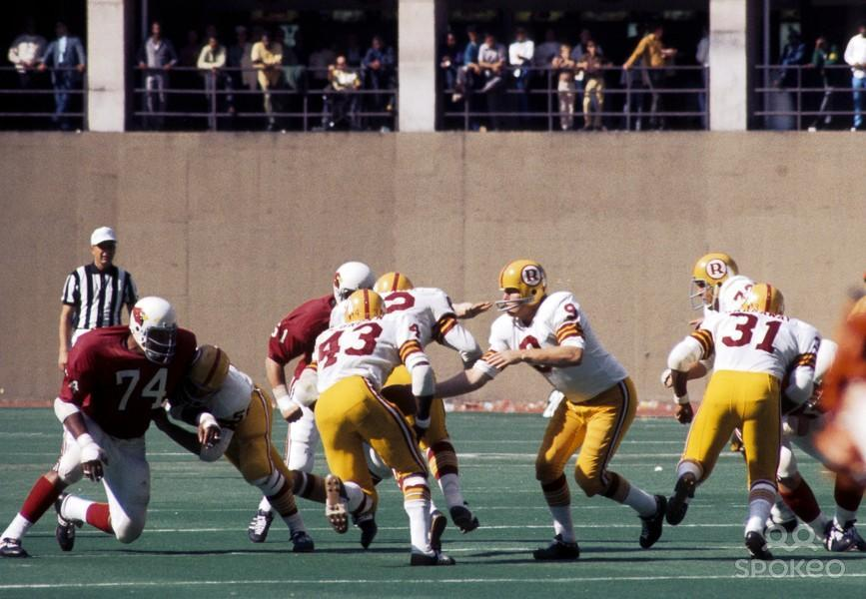
Figure 5A. 1

Following the initial uniform release, the redesigning of the Washington Warriors stadium, FedEx Field, will begin. Every single artifact mentioning the Redskins at FedEx Field must be changed, which is a laborious process to undergo. All concession stands, team stores, ticket booths, and banners will need to be altered. During this same time, the Washington organization will implement the new field art onto FedEx Field. In addition to the redesign at FedEx Field, the Washington Warriors training center will also undergo the same process. This process will serve to distance the new-look Washington Warriors from their past looks, and help to further foster a new and exciting identity for the team.
Shortly before the NFL Preseason kicks off, the newly redesigned field will then be opened up to the public at an open media event. The Washington community can come enjoy the new Warriors stadium with free food and activities for the day. Warriors players and coaches will also be available for public appearance at the event, allowed to further promote the new brand. This will allow Washington fans and the surrounding DC community to get a feel for what FedEx Field will look like for the future and see the new look Warriors, both of which serving to stimulate regional target market interest in the upcoming 2014-2015 Washington Warriors season.
To conclude the rebranding process, the Washington Warriors will enter an intensive social media advertising running through the NFL Preseason in order to further spread the word to all NFL fans about the new image of the Warriors. Utilizing both Facebook and Twitter will allow for the organization to reach mass markets simultaneously.
B. Proposed Activities and Timelines
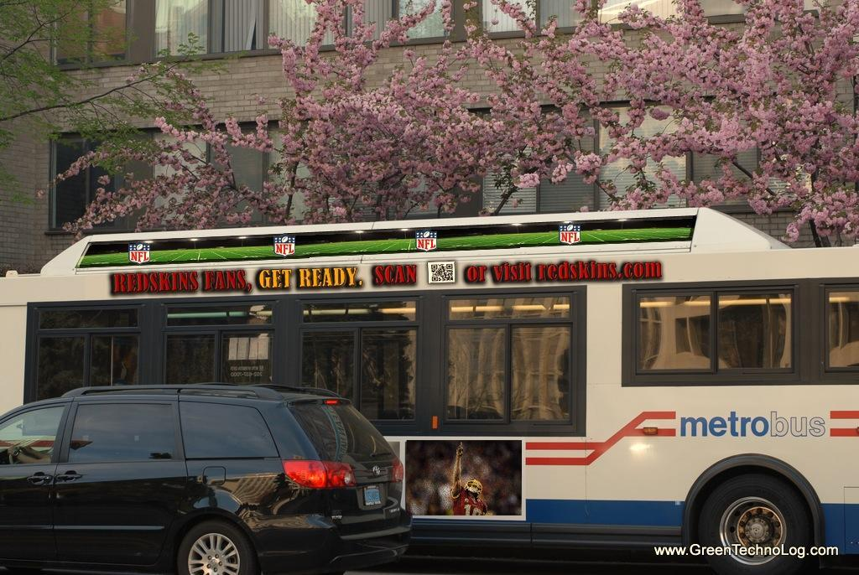
Figure 5B.1
In the final 2-3 days of April 2014, the initial advertising campaign will begin. A series of large advertisements will be placed on both DC Metro buses and trains, inside and out. They will feature large text in Washington’s Maroon and Yellow colors saying “REDSKINS FANS GET READY.” This will then be followed by a scannable QR code, which will lead viewers to a subsection of redskins.com. On this website will be an announcement of the rebranding, as well as a countdown to the release of the new logo and name. A sample advertisement that would be placed on the DC Metro system is provided in Figure 5B.1.
In the early morning hours of May 11th, the day immediately following the conclusion of the NFL Draft, the current “redskins.com” domain will be changed and visitors redirected to “dcwarriors.com” (due to the current registration of “warriors.com” to the Golden State NBA organization). At this same time on May 11th, “dcwarriors.com” as well as the Washington Warriors mobile apps and social accounts will be updated to reflect the recent brand changes. This will be done utilizing both the current social media team of the Warriors as well as a contracted web and mobile design team.
An early concept logo of the new Washington Warriors is pictured in Figure 5B.2.
Figure 5B.2
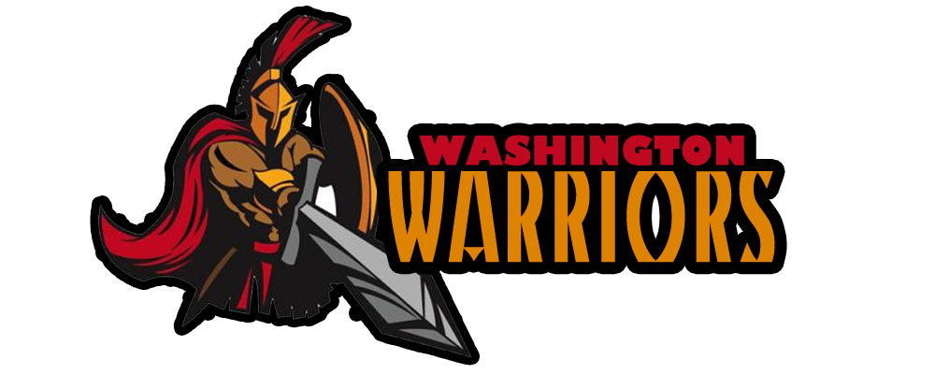
The new logo of the Warriors will feature the classic dark-red and yellow of the Redskins, yet with a new, completely modernized look. On the left there will be a menacing warrior figure wielding a sword and shield, and on the right the trademark “Washington Warriors” name. This intimidating logo will offer a new look to the organization while still retaining some of the “tribal warrior” essences from the organization’s past.
During the week of May 18th, two weeks following the initial logo/name release, the official 2014-15 uniforms of the Washington Warriors will be released to the general public. The new uniforms, designed by Nike, will feature a modern look similar to that of the Seattle Seahawks. An early prototype is pictured in Figure 5B.3.
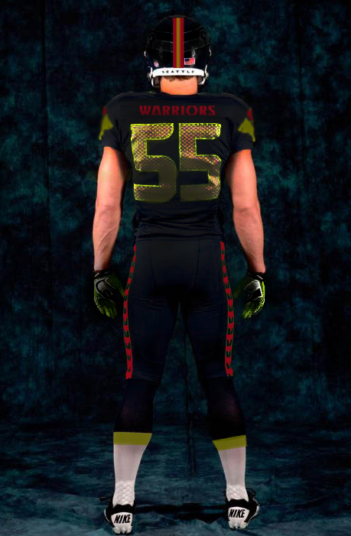

Figure 5B.3
The Warriors will wear an intimidating all-black uniform at home, and a clean white/gray uniform on the road. In addition to these two main uniforms, the Warriors will also feature a “throwback” alternate jersey to be worn 2-3 games per year. This “throwback” alternate jersey will be voted on by the fans, and will be one of 3 Redskins’ past uniforms before 2000. Fans can go to the Warriors website shortly following the release of the initial uniforms to vote and see current poll results. To release the initial uniforms, a press conference will be conducted in cooperation with Nike to model the new uniforms on current Warriors players and professional models. Additional media releases will be conducted on Warriors social media accounts.
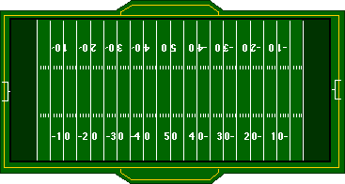
In the final three weeks of May the Washington Warriors will completely redesign FedEx Field as well as the Warriors training center to fit the new brand. This means everything from the team store to concessions will need to be completely designed to model the new logo and name of the Warriors. Signs featuring the old Redskins logo will be replaced by the new Warriors logo, and will be reflected to the updated image. Additionally, the team store will be updated to feature the new jerseys and apparel of the Warriors. At this same time, the new Warriors field art will be implemented onto FedEx Field, which is pictured below in Figure 5B.4.

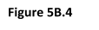

After FedEx Field is complete with its renovation in the end of May, with a week to spare before the NFL Preseason kickoff, the Warriors will hold an Open Field day at the stadium to celebrate the rebranding and the upcoming season. This will take place at a time right when fans are getting back into the sport. The stadium will be open to members of the Greater Washington DC community to visit, and to enjoy free food and activities for the whole family. In addition, Warriors players and coaches will attend the event to meet members of the community, participate in family activities, and answer a few media questions regarding the rebranding transition. Press will be present at this event.
To wrap up the rebranding process, in the concluding week before the preseason kicks off, running until the start of the official NFL season, the Warriors will initiate an intensive social media campaign. Tweets using “#WarriorsForTheWin” will be tweeted and shared using the Warriors twitter account, creating a catchy phrase for Washington fans to use. Tweets and posts will also be sent out regarding the final voting of Washington’s alternate uniform, the upcoming season, and where to buy tickets. This will all be conducted under the current Washington social media department of the organization.
It is important to note that with all of these activities set to take place, in recent years the NFL has undergone a lot of scrutiny for the length of its pre-season schedule. Many players feel it is too long and many fans state that it is unfair to charge regular price for a home game that is played poorly and by future practice squad players. Last season the Dallas Cowboys and the Miami Dolphins started the preseason in Canton, Ohio for the Hall of Fame Game on August 4th. While both teams played a total of five games that preseason; most teams took part in a four game preseason schedule that started August 9th and concluded August 29th.
At the end of the season the NFL looks at how teams finish and creates the schedule for the following season based on those results. Since the draft has already been moved from Late April to May 8th-10th; one may also be led to assume that changes elsewhere are set to occur. Since the NFL has not solidified those dates, we will use last years schedule as a reference for our campaign this year. Should the league introduce a new calendar we will adjust ours accordingly.
VI. PROPOSED BUDGET
A. Costs Associated With Proposed Rebranding Strategies
Below we have listed a general table, Figure 6A.1, displaying the projected costs of each activity of the rebranding process. The total cost is estimated to be around $14-$14.5 million.
Figure 6A.1
WASHINGTON WARRIORS REBRANDING COSTS
Details of Expense | Amount of Expense
Place ads on DC Metro subway/bus lines with a scannable QR code, hyping up the future rebranding | ~$150,000-$200,000 for 40-50 ads placed on both buses and subways
Unveil new logo and name online; Initiate website/social network redesigns, as well as iOS/Android app redesign | ~$200,000-$250,000 for the services of a professional graphic designer, website designer, and app designer
Redesigned uniforms/helmets/apparel | ~$400,000-$450,000 for redesigned helmets, uniforms, and coaching apparel
Press conference to release uniforms | ~$60,000 for uniform modeling, media hosting, and space renting
Redesigning FedEx Field and training field, concessions, and banners to fit new brand | ~$11.5-$12.5 million. Main costs reside in completely changing the letters on the top of both FedEx Field and the Training Center. Rest of costs reside on field redesign, banners, concessions, etc.
Offer new stadium viewing for fans, with games for kids and free food | ~$50,000 for food, concessions, and games to be made available at the stadium
Kickstart an intensive social media campaign on Twitter, Facebook, and Instagram | Free of charge under current Social Media department

We will further break down the costs listed in Figure 6A.1.
Starting off with the DC Metro advertising campaign, we estimated these costs to total around $200,000. Since the DC Metro system did not list specific prices for advertising opportunities on their website, my partner and I took into account the listed costs of advertising of other public transportation systems in major urban areas, namely New York City, Charlotte, and Boston. This price will cover an estimated 40-50 advertisements placed strategically on trains themselves, inside the trains, on the inside and outside of buses, and inside actual Metro transport stations.
The next phase, designing and revealing the new logo and name online as well as completely redesigning the websites and social media accounts, is estimated to cost around $250,000. This high cost is mainly due to the necessity of working with an extremely high-quality graphic designer to make sure the new logo is completely flawless and ready for mass use. The rest of the cost will be paid to a contracted team of website and app designers to implement the new look and logo into dcwarriors.com as well as our mobile apps in a timely manner.
The following phase, ordering all of the redesigned uniforms, helmets, and staff apparel is expected to cost around $400,000 up to $450,000. This cost covers the ordering of six complete gameday uniform sets per player (two home, two away, two alternate), a set of three complete practice uniforms and one apparel set per player and practice squad member, an estimated 150-175 helmets in total, two polo shirts and a visor per staff member, and one set of various Warriors apparel per player. This pricing is based off of information on Nike’s website, specifically their online shop which contains a vast amount of prices for shoes, football uniforms, polo shirts, hats, and apparel. Current Redskins inventory in storage will be sold at reduced prices to help offset this high cost. The press conference to release these uniforms is estimated to cost under $75,000, which covers the renting of a venue, the paid speaking of various Nike executives, and the professional modeling of the uniforms.
The next and most expensive step is the redesigning of FedEx Field and the Warriors Training Center. A significant percentage of the cost covers the replacement of the large “WASHINGTON REDSKINS” metal letters that are mounted on to the Eastern side of FedEx Field. Taking down these large letters, ordering new ones that display “WASHINGTON WARRIORS”, and completely installing them will cost a few million dollars. The rest of the estimated $7 million to $8 million left over will go towards redesigning the field art, the team stores, concessions, bathrooms, banners, and any and all references to the Redskins. Some of these same costs also apply to the redesigning of the Warriors Training Center. These projected costs are based off of an online news article from BusinessWeek, which somewhat breaks down the cost of a fictitious Redskin rebrand specifically with FedEx Field.
The last step of this rebranding process that is of monetary cost is the FedEx Field Open House. This will cost an estimated $60,000 or less, covering paid speakers, catered food, stadium staff wages, event coordinator wages, games, and public appearances.
The final rebranding event to occur, albeit no monetary cost, is the intensive social media campaign. This will not contribute in any way to the cost of the rebranding, as this can be achieved under the currently salaried social media team of the Warriors.
B. Proposed Metrics to Measure Return on Investment (ROI)
With the rebranding of this organization projected to fall around $14 million, we reasonably also expect that the Washington organization would need to see a reliable source of ROI projections to continue. This subsection will discuss the projections of future revenue, and its relation to the rebranding process being made.
To begin, we have listed a table below, Figure 6B.1, to demonstrate ways to initially display the individual effectiveness of separate aspects of the rebranding process.
Figure 6B.1
Details of Expense | Tracking Effectiveness
Place ads on DC Metro subway/bus lines with a scannable QR code, hyping up the future rebranding | Track amount of times QR code has been scanned/visited. Also track the amount of times that the countdown website has been visited by those who have not scanned the QR code.
Unveil new logo and name online; Initiate website/social network redesigns, as well as iOS/Android app redesign | Amount of online viewers, and viewers of related writings of the unveiling. Also allow for fan reaction on the site. View new app ratings on the iOS App Store and the Google Play Store (iOS and Android markets).
Redesigned uniforms/helmets/apparel | Allow a section on the website for fan reaction. In addition, view the amount of times that the various media releases of the uniforms has been viewed and shared by fans.
Press conference to release uniforms | Look at all articles published online about the release, and account for the total overall number of readers.
Redesigning FedEx Field and training field, concessions, and banners to fit new brand | Upload new field design online, track amount of viewers, allow for fan reaction, further community reaction will occur at the following Open House event.
Offer new stadium viewing for fans, with games for kids and free food | Allow for media to cover event, gauge responses online and through customer response cards given out to DC community members who attend event.
Kickstart an intensive social media campaign on Twitter, Facebook, and Instagram | Track the amount of new followers, new retweets, favorites, friends, etc., from the current values.

We will begin by breaking down Figure 6B.1 and explaining the rationale of each effectiveness measure, and then conclude by talking about the overall expected value increase based off of case studies of recently rebranded NFL teams.
The success of the initial advertising campaign can be easily tracked via the monitoring of web and QR traffic. QR traffic, in this instance, would be traceable using a service called the QR Code Scan Report. For $150 (based off of assumptions due to the company size and needs), the organization could track, minute by minute the live traffic of the QR code and observing how many times it has been scanned. This service will also allow for the organization to observe percent increases over any given amount of time, and break down traffic by time of day. Web traffic of the countdown site can already be traced using the team’s Webmaster at no additional charge, and will also give a good indication of people visiting the site that have not seen or scanned the QR code. These will increase projected 2014-2015 sales due to the sharply increased publicity regarding the initial announcement of a rebranding. The team will be given more attention by media and fans, thus leading to more revenue.
The success of the new logo is hard to project due to its subjectivity, but we can base our projections in the short term off of fan and media reaction to the logo. On dcwarriors.com, we can create a section for users and visitors to leave their comments about new look, and provide either a “thumbs-up” or “thumbs-down” rating. Relating the success of the logo and name to ROI, this will give a general feel for the organization regarding whether or not their overall brand value will see an increase over the next few years. If fans like and support a team more than before, then it is reasonable to expect an increase in the organization’s brand value. Concerning fan reaction over the new website and mobile app layouts, we can simply observe mobile marketplace ratings over a set period of time using granted application developer tools on the iOS and Android platforms, and look at fan reaction regarding the website change in a comment section. Having a well rated, enjoyable website for fans to visit will make it more likely for others to download our mobile app and visit our website, all the while gaining the organization important publicity. This will go to contribute to the increased projected revenue next year.
For the uniform releases, effectiveness can once again be tracked for both publicity and expected brand value increase. To test publicity increases (and thus short term projected revenue increases), we can use Webmaster tools to determine the percentage increase in web traffic for the 2-3 days immediately following the online release of the uniforms, as well as observe the amount and traffic of other web articles concerning the uniform release. To test the potential for brand value increases, we have to look at fan reaction once more. This can be done by observing fan reactions in a comment section placed on the team website, as well as various other online reviews. If the observed online crowd deems the new uniforms popular, they are expected to further enhance the brand image value increases of the organization.
Since there is going to be considerably less publicity for the new looks of FedEx Field than the reveal of the logo or uniform, it is difficult to associate this with any potential revenue increases strongly. However, perhaps some fans looking for a new experience will enjoy going to games at a redesigned FedEx Field to cheer for the Warriors, thus marginally increasing projected revenue. This action does, however, go to strengthen the new brand of the Washington Warriors and will predictability lead to a brand value increase over time. Fan reaction on a comment section online can also be factored in to help project future brand value, as well as community reaction from the Redskins Open House event. Response cards can be handed out to community visitors and be taken into consideration in this case.
The final social media campaign is additionally simple in terms of measuring effectiveness. The organization can simply take counts of social media friends and followers both before the Metro campaign and before the social media campaign, and compare it with updated counts at the resolution of the rebranding. This will show how many new people started following the team on social networks throughout the entire process, and more specifically the social media campaign, all demonstrating increasing publicity due to the rebranding. This, once more, leads to increasing projected revenue.
For a brief comparison to accurately project the real values of these estimated revenue increases and value increases, we can look at the example of the Jacksonville Jaguars, who were the most recent NFL team to undergo any sort of brand/logo change. In 2012, the team partially rebranded themselves, coming up with a completely new uniform design and logo. This created a huge spike in interest in the team from both fans and non-fans, leading to an impressive 9% overall revenue growth rate after years of stagnancy. The Jaguars, this current season, also set their all-time franchise record for single-season attendance, indicating that even a partial rebranding will garner increased interest from fans. Since the Jaguars only partially rebranded and play out of a notably smaller market base, it is very safe to say that the Washington Warriors, if to rebrand, would undergo one of the highest, if not the top, revenue percentage increases in the league for the 2014-2015 NFL season, due to their sheer market size and the depth of the brand overhaul.
My partner and I strongly believe that all of our rebranding activities will contribute to both greater publicity (leading to increased revenue), as well as a strengthening and refreshing brand image that is sure to solidify itself in Washington, D.C. and all over the world. These two factors will lead to a significant growth in overall value and will make the original $14 million dollar investment a sure winner. We feel confident saying this not based solely on our own descriptive projections, but additionally looking at the quantitative facts and results of other rebranding successes, such as in Jacksonville. With our market mass and the size of the rebranding that we are going to undergo, our revenue growth can be almost certainly the highest in the league this upcoming season due to the very probable surge in attendance and publicity that will come.

VII. BIBLIOGRAPHY
- http://www.profootball.nbcsports.com/boston-globe-calls-for-redskins-to-change-name
- http://www.washingtonpost.com/local/redskins-owner-dan-snyder-makes-visits-to-indian-country-amid-name-change-pressure/2013/12/21/5f939266-6777-11e3-a0b9-249bbb34602c_story.html
- http://www.nationalreview.com/corner/367713/anti-redskins-tribe-disputes-poll-showing-support-name-andrew-johnson
- http://www.washingtonpost.com/local/pork-rinds-cant-be-sold-under-trademark-redskins-hog-rinds-agency-rules/2014/01/06/954feea4-7726-11e3-b1c5-739e63e9c9a7_story.html
- http://www.usatoday.com/story/sports/nfl/redskins/2013/11/12/president-obama-oneida-indians-washington-nfl/3511001/
- http://www.csmonitor.com/USA/Latest-News-Wires/2013/1113/Obama-Redskins-name-offends-a-sizable-group-of-people.
- http://www.reddit.com/r/nfl
- http://www.nike.com
- http://www.businessweek.com/articles/2013-06-13/renaming-the-redskins-4-new-not-racist-names-and-logos-for-d-dot-c-dot-s-nfl-team
- http://www.forbes.com/teams/washington-redskins/
- http://www.forbes.com/teams/jacksonville-jaguars/

