Hendrick Automotive
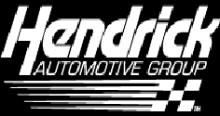
Buying And Merchandising Marketing Operations Research

Ardrey Kell DECA Chapter
Ardrey Kell High School
10220 Ardrey Kell Rd
Charlotte, NC 28277
John Dwyer
January 1, 2014

- Executive Summary
- Introduction
- Description of the business or organization
- Description of the community (economic, geographic, demographic, and socioeconomic factors)
- Overview of the business or organization’s mission, target market, and existing branding efforts
- Research Methods Used in the Study
- Description and rationale of research methodologies selected to conduct the research study
- Process used to conduct the selected research methods
- Finding and Conclusions of the Study
- Findings of the research study
- Conclusions based on the findings
- Proposed Rebranding Plan
- Objectives and rationale of the proposed rebranding plan
- Proposed activities and timelines
- Proposed Budget
- Costs associated with proposed rebranding strategies
- Proposed metrics to measure return on investment (ROI)

- Executive Summary
Summary of Business: Hendrick Automotive is the 6th largest ‘mega-dealer’ of cars in the United States; Hendrick is based in Charlotte, North Carolina where they have 11 new and used car dealerships. Hendrick runs a bone marrow foundation that helps raise awareness and money for the cause.
Findings and Conclusions: We contacted 50 Hendrick customers and asked them to take a survey on their experience buying a car with us, we received answers from all of them. There was an overall opinion of Hendrick dealerships being quality dealerships with good service, but the downfall is that prices can be a bit higher than other dealerships.
Proposed institutional promotion campaign: We want to start a marketing campaign that will attract possible customers from the 18-22 year age group and their parents, who are looking to buy their first new car
Goals:
- Attract young buyers in the 18-22 year age group and their parents
- Promote easy buying process
- Promote low prices
- Promote quality discounts
Activities:
- New ad campaign
- Discounts for buyers in 18-22 year age group

- Introduction
  - Description of Business
Hendrick Companies LLC is one of the most prominent automotive companies on the east coast with two different sects of the company; Hendrick Automotive, running the car dealerships, and Hendrick Motorsports, running the racing side of the company. In 1975 Rick Hendrick had his first opportunity to own a dealership, a failing Chevrolet dealership, in the farming town of Bennettsville, South Carolina. At only 25 Hendrick was the youngest person to ever own a Chevrolet dealership in the United States. Hendrick Automotive is headquartered in Charlotte and has 87 Hendrick dealerships that represent 29 nameplates, 121 franchises and 24 collision centers and three accessories distributor installers that are located in a total of 13 states: Alabama, California, Florida, Georgia, Kansas, Louisiana, Maryland, Missouri, North Carolina, South Carolina, Tennessee, Texas, and Virginia. The company’s headquarters are in Charlotte, North Carolina and the largest customer base is in Charlotte as well. The newest Hendrick dealerships, Hendrick BMW, Lexus, and Mercedes, are just outside of Charlotte. Within the next year Hendrick Automotive plans to open 20 more dealerships. Below is a map that depicts the geographical regions that Hendrick Automotive operates in.
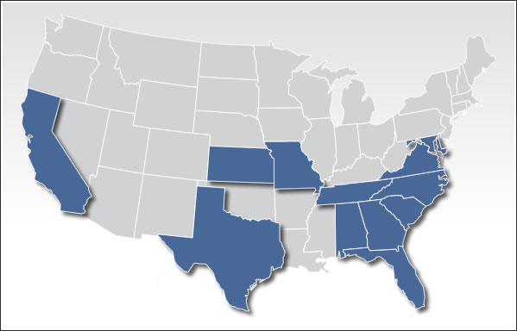

- Description of the Community
  - Economic
The dealership that we are focusing on is located in Charlotte, North Carolina at 5101 E. Independence Blvd., Charlotte, NC 28212. We chose this location because it is one of the more prominent dealerships under Hendrick Automotive’s control.
Charlotte’s economy is characterized by banking, tourism from NASCAR races, the city’s Charlotte/Douglas Airport, and a growing population. There are 286 Fortune 500 companies in Charlotte along with 1200 manufacturing companies that are influential in American industry. As of 2012 there are 775,202 people living in the Charlotte area with an average income of around $50,177 per year compared to $43,916 throughout the rest of the state.

b. demographic
The major racial make-up of Charlotte is 45.5% White, 33.6% Black, 13.3% Hispanic, 5% Asian, 2.2% is two or more races with the remaining percentages being ‘other’, American Indian, and Native Hawaiian/other pacific island.

C. Description of the business or organization’s mission, target market and existing branding efforts

The culture at Hendrick Automotive is based around their mission to be the premier quality vehicle retailer in the world, providing the best opportunities for their team members, customers, communities, and the manufacturers they represent. Hendrick Automotive has achieved their mission and remains the industry’s leader by following the “Hendrick Advantage,” a set of core values that the company stands by. The Company Founder, Rick Hendrick, paved the way for one of the most successful companies on the east coast, selling over 150,000 cars last year (2012) and employing over 8000, the company is the sixth largest “mega-dealer” in the nation. Our most successful dealership Hendrick Chevrolet and Cadillac currently targets middle class customers with Chevrolet vehicles and middle to upper class customers with Cadillac vehicles.
What needs to change is the public’s opinion on what vehicles they can buy from us. Through ad campaigns we will show that possible customers outside of the middle to upper middle class can afford Chevrolets and Cadillacs when they buy from us because we can give them discounts that other dealerships cannot. Because Hendrick is such a successful dealership we have the ability to lower the cost to buy these vehicles so that these possible customers can buy them.
- Research Methods Used in the Study
  - Description and rationale of research methodologies selected to conduct the research study
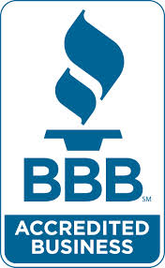
When planning a new marketing campaign for Hendrick Automotive, I conducted research that included both primary and secondary research, and followed the processes one would use in the marketing industry. For my secondary research I used websites such as Yelp.com and www.BBB.org (Better Business Bureau) I chose to use these two websites for my secondary research because they are reputable websites that post a lot of consumer opinion and company profile information. For my primary research I chose to conduct an email survey because it allowed me to contact a large group of people using a program that was inexpensive and allowed me to not only collect, but analyze data easily.
  - Process used to conduct the selected research methods
When examining yelp and bbb.com I was looking to find what the public opinion of Hendrick Automotive was and to see if anybody had posted negative reviews so I could evaluate them. The Better Business Bureau website that rates a business’s reliability, integrity, and performance. Hendrick Automotive is rated an “A+” on a scale of “A+ to F.” The scale used to grade companies is based on 16 factors, including a Business' complaint history with the Better Business Bureau, the type of business they are, the amount of time they have been in business, as well as other factors relating to customer opinion and experience. I also used the website Yelp. On this website customers of the business can go on the internet and leave reviews and ratings based on their experiences with the business so that others can see the reviews, discuss their opinions, and visit locations that stand out. According to Yelp, Hendrick Automotive received an average customer rating of 4.5 out of 5. Both of these websites allowed me to judge the opinions of the business held by the public.
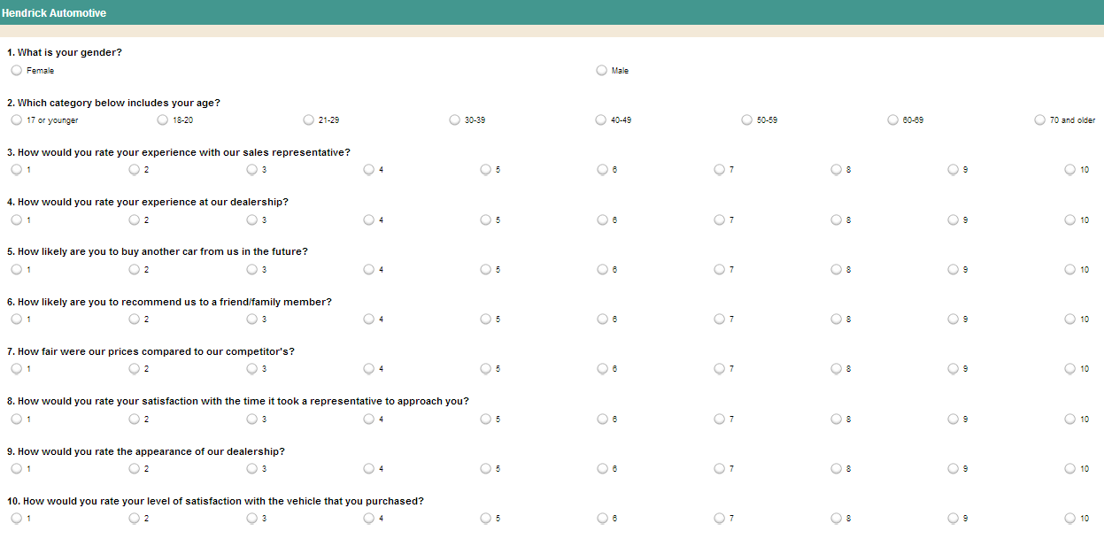
In order to gather primary data, I conducted a survey of 50 Hendrick Automotive customers regarding their experience buying cars from Hendrick Automotive (Further research in progress). I got the email addresses of these customers through my father who got the emails from a Hendrick Executive. The customers that I surveyed were chosen by the Hendrick executive randomly, except that they had all purchased a car from Hendrick within the past 6 months. The survey was 10 questions long and had the sample group rate different aspects of their experience on a scale of 1-10, 10 being the best. I used the website Survey Monkey to create the survey and I am using Survey Monkey to calculate the results. I chose this format for the survey because it was convenient for the sample group to respond to and would increase their motivation to take part and answer honestly. The survey asked customers questions like “How would you rate your experience with our sales representative?” and “How likely are you to buy another car from us in the future?” The survey was emailed to the 50 customers that I chose based on. This distribution method was chosen because it was most convenient for all parties and because responses would be quick and computerized. All 50 people in the sample group have responded to the survey and results were collected and analyzed. (update) I have contacted the marketing department at Hendrick to see if they have done any surveys that they can release and I am waiting for a reply. (update) The Hendrick Automotive marketing department cannot release any surveys to me due to a company policy.

IV. Findings and conclusions
- Findings of the research study
The findings portion of this report will include data compiled from the primary and secondary research that was conducted. This data will show the level of the satisfaction of Hendrick Automotive’s customers.

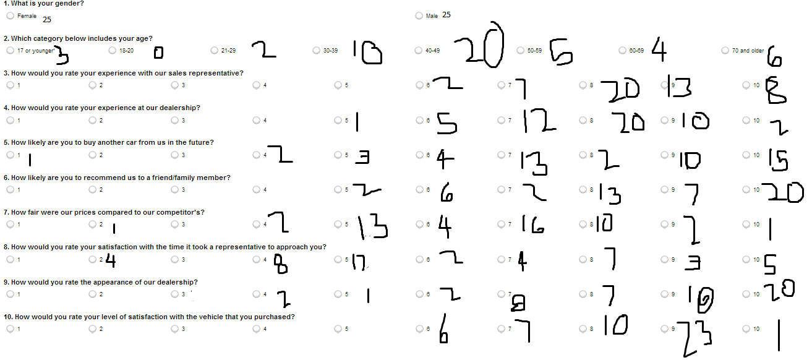

This is the survey given to the 50 individuals in the sample group, there are 10 questions.
These are the results of the survey; the data shows that overall customers are usually satisfied with their experience buying a car from Hendrick Automotive, but there were a few people who did have slightly less acceptable visits to the dealerships.
- Conclusions based on the findings
Based on the findings of the survey I can conclude that this particular Hendrick Automotive dealership has strong customer service but seems expensive and lacks low cost models for the lower to middle class citizen. From the Yelp.com research I discovered that promotions from the dealerships were minimal and brand awareness was low. The first suggestion I would like to make is to start an advertising campaign that emphasizes the focus on a quick and easy visit to the dealership so that people are aware of our efficiency and that we can promote ourselves as a dealership that has worked to improve our customer wait time. This strategy can be a quick fix to the 4 low ranks on question 8. My second suggestion is to rebrand Hendrick Automotive so that they can compete more directly with their number one competitor, Sonic Automotive. Hendrick will need to start focusing more on the prices of the competitors because they are viewed as more expensive and as a result less likely to be purchased from by younger consumers.
- Proposed Rebranding Plan
  - Objectives & Rationale of the Proposed Rebranding Plan
The objective of my rebranding of Hendricks Automotive is to attract younger customers, particularly within the age group of 18 to 22. The 18 to 22 age group is the group that the lowest amount of sales exist in. After conducting my research I have come up with three possible choices to rebrand Hendrick Automotive. The first option would be to start a marketing campaign aimed at the under 22 age group using a variety of advertisements including television, internet, and magazine.
In addition to the increased promotions there would be a discount for high school students, high school graduates, and full time college students. I believe this will be effective because the lower prices will attract the 18-22 age group who are still in school and who may not have incomes sufficient enough to purchase high price models.
I would also try to market smaller cars to college students. I believe this is an effective strategy because college students usually don’t have many people to drive around, and are looking for more fuel efficient models.
  - Proposed Activities and Timelines
Based on my target market and my goals for that market there are a few ways that I can advertise to them. I want to increase TV, internet, and magazine ads on television channels and magazines popular with 18-22 year olds, and on websites that are popular with that age group. I want to advertise on television channels such as MTV, Comedy Central, and FX. I also want to target the parents of people in this age group because it is highly likely that the parents will play some part in the car buying process, I will so by advertising on ABC, NBC, CBS, and Fox News Channel. The commercial will depict a young person in a Hendrick car dealership with their parents buying their first new car. This advertisement will show how easy it is to buy a car in our dealerships because of our friendly staff and low prices. The magazine and internet ads will depict the same ideas, just in a still picture format. This ad campaign will run under the slogan “We make buying your first car quick and simple.” The ad campaign will begin July 1, 2014 when high school students are finishing a grade level or graduating, this is also around the time when college students are coming home from school for the summer and end in mid-August when students are going back to school

- Proposed Budget
- Costs associated with proposed rebranding strategies
Placing an advertisement on a major television network such as NBC, ABC, or Fox News channel would cost anywhere from $110,000 to $200,000 per 30 second commercial. An internet ad could cost as low as $30 per day. To maximize exposure and keep costs low the ads would be spread out on each channel and we would try to avoid primetime television for the sake of keeping down costs.
- Proposed metrics to measure return on investment (ROI)
The best way for Hendrick to measure the return on investment would be as simple as asking the customer to tell our salesperson where and how they heard of our dealerships and for the salesperson to ask the customer their age when working out payment details and having the salesperson record that, then all of those records would be sent to our marketing division. When the ad campaign ends in August of 2014 our marketing division would analyze the amount of customers in this age group by looking at the records that were given to them and comparing it to the costs of the ad campaign.

