Extended Stay America
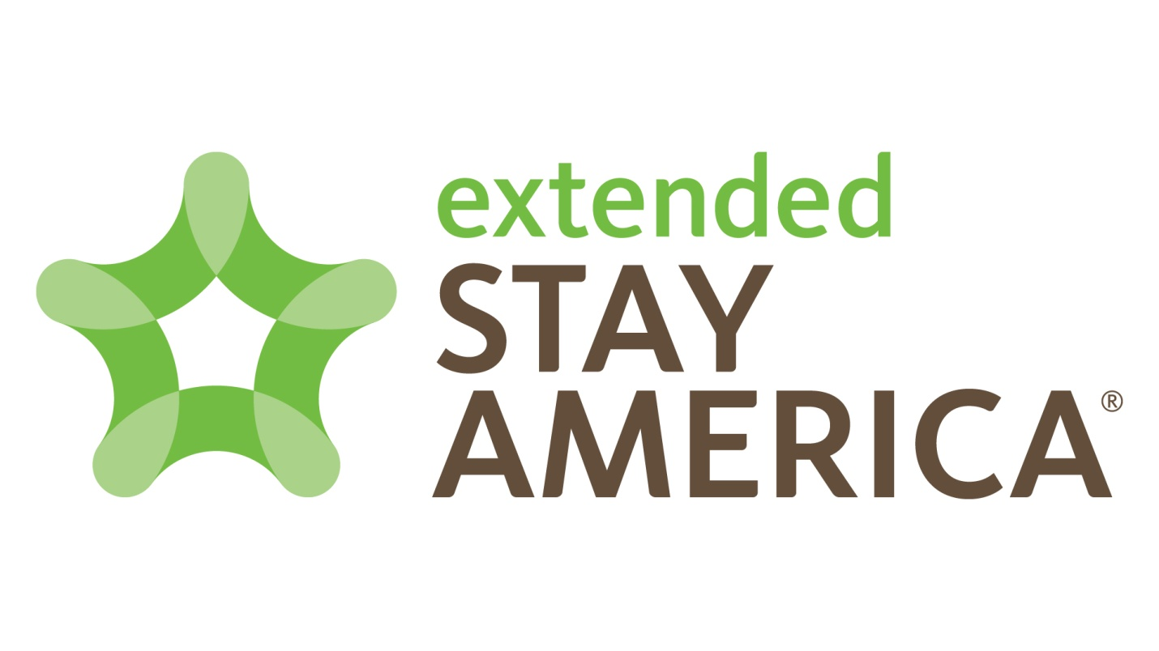
INTERNATIONAL BUSINESS PLAN EVENT
Hotel & Lodging

Ardrey Kell DECA
Ardrey Kell High School
10220 Ardrey Kell Road
Charlotte, North Carolina 28227

Devon Atkins & Vince Legrasso

February 4, 2015

Table of Contents
- EXECUTIVE SUMMARY

- INTRODUCTION

- ANALYSIS OF THE INTERNATIONAL BUSINESS SITUATION
- Economic, political and legal analysis of the trading country
  - Describe the trading country’s economic system, economic information important to your proposed business/product/service, the level of foreign investment in that country

  - Describe the trading country’s governmental structure and stability, how the government controls trade and private business

  - Describe laws and/or governmental agencies that affect your business/product/service

- Trade area and cultural analysis
  - Geographic and demographic information, important customs and traditions, other pertinent cultural information, competitive advantages and disadvantages of the proposed product and/or service

  - Market segment analysis target market (age, income level, population estimate, other specific demographic and economic information) customer buying behavior related to the proposed product and or service

  - Analysis of the potential location—importance and requirements of each trade document required by the U.S.A. and/or Canada and the country of choice

- PLANNED OPERATION OF THE PROPOSED BUSINESS/PRODUCT/SERVICE
- Proposed organization

- Proposed product/service
  - Details of the product(s)/service(s) to be offered; include potential suppliers, manufacturing plans, inventory policies, if applicable. If the business is a service business, appropriate information about plans to provide the service, including necessary supplies

  - How the product/supplies will be transported to/from the home country

- Proposed strategies
  - Proposed pricing policies

  - Proposed promotional program, promotional activity(ies), media availability, costs, one-year promotional plan outline

- PLANNED FINANCING
- Projected income statements for first year’s operation (sales, expenses, profit/loss)

- Projected balance sheet for the end of the first year

- A brief narrative description of the planned growth of the proposed business, including financial resources, needs and a brief three-year plan projection

- BIBLIOGRAPHY

- APPENDIX

- EXECUTIVE SUMMARY

- INTRODUCTION

Whether someone is traveling for business, looking for temporary or corporate housing, needing short-term housing during relocation, or even if they’re planning a weekend getaway, Extended Stay America is without a doubt the perfect solution that will fit just about every budget, with great nightly rates, budget weekly rates and discount long-term rates. Each of Extended Stay America’s spacious suites offers a fully equipped kitchen, free Wi-Fi, a flat-screen TV with premium channels, free grab-and-go breakfast, and on-site laundry facilities. These hotels offer family-friendly (kids stay free) and pet-friendly hotel suites in nearly 700 locations throughout the United States and Canada, with long-stay hotels in most major cities.
Extended Stay America is the convenient, affordable hotel choice for savvy business and leisure travelers alike. With the great success Extended Stay America has shown to have in The United States and Canada, we have decided to expand this overseas. Italy on average makes 47.7 million dollars a year on tourism, rendering it a perfect place to set up locations for not only tourists/vacationers, but even those looking for a temporary place to relocate to or stay while on business trips.
Location is huge when setting up a new business, which is why we‘ve chosen to open up 3 locations in Italy. The first location is in Rome, this is the capital of Italy and has the highest population. The second one is Naples, which ranks third in population but has a great public transportation system. Lastly, comes Milan, which has the second highest population in Italy. These three locations will be our sample group/”test run” to make sure this business idea can flourish and grow throughout the rest of Europe.
Finding a target market can be difficult with the business we chose. Therefore, we’ve selected our target market as males and females, ages 20-50. This age range is generally the time in peoples lives where they are getting a job, already involved in work that may require international travel, relocating or moving into a house of their own, and also just taking vacations and touring different popular locations, such as Italy. Also, traveling to different countries can cost a good amount of money, which usually means they’re a bit older and have enough money to support their travels.
Our target market doesn’t only include people coming from outside of Italy, but also the people already in Italy. We will be attempting to partner up with a well known tourist company, which will then allow for different promotion and advertising opportunities. Overall this is a great fit for our company, Extended Stay America, and the chosen tourist company to partner with because not only will our customers be more likely to use their services for tours, but their customers will be more likely to stay with us because of the partnership.
- ANALYSIS OF THE INTERNATIONAL BUSINESS SITUATION
- Economic, political and legal analysis of the trading country
  - Describe the trading country’s economic system, economic information important to your proposed business/product/service, the level of foreign investment in that country

People might ask why we picked Italy and there are many reasons as to why we chose to do so. For one, it is one of the most popular countries in Europe. Italy also has great relations with the U.S.A (61% of Italian citizens agree with American politics). With the great relations and desirable attractions Italy has to offer, we found this to be a great place to start out.
Italy has an industrial diversified economy. The northern region of Italy is dominated by private industries and the southern region is mostly dominated by poor agricultural. In 2013, the Italian labor force was recorded at 25.74 million people. Due to the cost of living in Italy many people need to work, making the labor force very large. Italy’s GDP is $28,376 per capita. The population of italy is 58.9 million people, and at least 25.74 million of those are in the workforce. This means that almost half of Italy has a career/job. With more than 47.7 million tourists traveling to Italy a year, it puts Italy at the fifth most visited country in the world, which means it will be a great place for our kind of business.
Italy actually lacks some of the necessary natural resources, but makes up for that in the applicable technology that's available. ENEA, the Italian National Agency for New Technologies, is a company focusing on alternative energy resources. ENEA is playing a huge role globally on advancements in alternative energy. Working conditions in Italy are very similar to other countries in Europe. The average work day is around eight to nine hours and the lunch breaks last for about two hours. The two hour lunch break may seem a bit extensive to Americans, but in Italy, meals are something that are highly valued. Tourism is the biggest industry in Italy, making over 47 million dollars a year, driving the Italian economy.
The main exports in Italy include machinery, vehicles, electronic equipment and many more. The major imports of Italy include mainly energy products, chemicals, engineering products and more. Due to the lack of natural resources, Italy looks to other options such as alternates.
Italy has an Industrial based economy. The economy is split into two geographic areas, the north dominated by private companies and big corporations, the south is a less developed area depending on agriculture. Northern Italy is where we will be starting up our company. The average income a year in the northern region is three times the amount it is in the south. Our service can be quite expensive therefore we need consumers who have a steady amount of income. 51.7% of Italy uses or has access to the internet. When we arrive to Italy we are going to launch a social media campaign to get the word out. According to The World Fact Book out of the 48.3% of the 51.7% lives in the northern region. The FDI of a country has a huge impact when trying to move a business internationally. Italy’s FDI is 1.4 percent compared to the average FDI of Europe 3.3 percent. This means that Italy will be thirsty for new and foreign companies. Italy’s FDI As of late Italy has had a hard time trying to find foreign investors. This will make our company even more appealing to Italy as they are having a hard time pulling in foreign corporations and investors.
Italy has been under heat lately with the sudden drop of economy. This is not what it seems though, Italy is not dropping, other countries around them are moving up on the world stage. For instance Italy has recently been passed in economic size by Brazil. Brazil has triple the population and 28 times the geographic space. Italy’s economy fits us perfectly and will help us thrive in our new market. The exchange rate is a big deal when moving internationally, 1 US dollar is equivalent to .79 cents. This does not mean that it will cost a lot of money to move over there. 79 cents there buys the same thing as 1 dollar does in the United States. The cost of goods in Italy comparative to the United States is similar. This means that there is not going to be an issue while we are moving. One obstacle we will have to overcome is going to be the use of the Euro. We are an American run company who only has only used the american dollar. Getting acquainted to a new form of currency and a new cost of goods will be tricky. With time this issue will diminish and we will be accustomed with the new culture and currency system.
  - Describe the trading country’s governmental structure and stability, how the government controls trade and private business

  - Describe laws and/or governmental agencies that affect your business/product/service

With any government there is always going to be set tax rates. The lower the tax rate the more income and profit you will pull in. Italy is in the top 10 of Europe dealing with tax rates. Italy’s tax rate is 23% and fluctuates from 19-30. The legislative branch in Italy holds a lot of power in the corporate world, and has set laws to restrict certain things. The legislative branch recently passed a law about foreign business coming to Italy. any company who comes overseas to Italy has to pay an additional tax rate for the first 18 months. Although the tax rate is low, it is still additional money we have to spend and will be a roadblock in our way. Other roadblocks we will run into will be getting employees in the new area, the language barrier and the new customs will be very hard to overcome. Overall the economy and government in italy will allow us to launch our business and become successful in italy.
- Trade area and cultural analysis
  - Geographic and demographic information, important customs and traditions, other pertinent cultural information, competitive advantages and disadvantages of the proposed product and/or service

In this section we would like to go deeper into just how our business functions. First we will talk about the global structure of the company. Considering we are moving our company across sea’s our ASP needs to be well defined. Our ASP for our three locations in Italy will be Rome, Florence and Venice. These cities are some of the most developed cities in Italy. The first location we have chosen is 150,000 Square Feet. The property is on the outskirts of Rome. The property comes out to 3,500,000. The location is close enough to the city for a nice car ride but far enough away from all the noise. 3.5 million may seem steep but due to the size and location this would be a great spot for our first location. This will be our pilot location, we will be collecting data off of this. Next we will be moving onto the functional structure, we are dividing our company into sub groups. We will have a specific branch in Italy dealing with public relations. In Italy public opinion is everything, therefore our P.R team will work day and night to make sure we have a smooth transition. The structure of our business will be reliant on our customers or a customer structure. Our service 100% relies on the customer, their feedback directly dictates how owe conduct our business.
  - Market segment analysis target market (age, income level, population estimate, other specific demographic and economic information) customer buying behavior related to the proposed product and or service

  - Analysis of the potential location—importance and requirements of each trade document required by the U.S.A. and/or Canada and the country of choice

- PLANNED OPERATION OF THE PROPOSED BUSINESS/PRODUCT/SERVICE
- Proposed organization

There's a lot of decisions that need to be made when a company is moving overseas. We will have to have clear communication between are overseas location and our locations in the United States. The decision making will be centralized, moving into a new market you have to be in complete control of all your decisions. Decentralized decision making is often out of control and all over the place. At the head of the chain will be our CEO, although there will be a board members, this is for checks and balances. In every branch there will be a “leader” or head of the branch. This will help the flow of work and keep everyone knowing what to do.
The business model we will be conducting is a franchise, because we already have an established company we will just be moving it into Italy. Extended Stay America is already an established company, therefore we are simply moving it overseas. This is efficient and effective, we do not have to go through the process of starting up a new company and establishing a market. These are two of the hardest things to do that fortunately because we are choosing to franchise a company.
Marketing research is key when moving to a new area, we have to figure out our target market and their incomes. Once we have this we can start an ad campaign targeting consumers. The location in which we are choosing to start our company is Rome, the most visited and most popular city in Italy. Extended Stay America is an established business who makes millions a year. This is very useful for our financial backing. Of course we will not be able to support it all by our self, but a large majority will be payed by the company. We will have to have financial backers, we will ask the same people who helped us when we first started. When we have to stock our locations we will be buying all the supplies we can in Italy. This will be supporting their economy and helping us achieve a positive public opinion. The supplies we can't get from Italy will be bought from the surrounding countries. When you are in the hospitality business insurance is a most. When are customers are staying at our hotel they are understanding that they are reliable for what happens. Although we will have insurance for extreme cases and weather and natural disasters. We will be hiring staff in Italy, this will help us with the language barrier. This is also helping with the theme of supporting Italy. Although higher level management will most likely be from a location in the United States. We have selected our location and have the set price for it. We have the deal lined up, all we have to is purchase the land. Our advertising plan will be heavily focused on what we bring to Italy. We will be putting money back into the economy, we will be hiring italians and helping that as much as possible.
- Proposed product/service
  - Details of the product(s)/service(s) to be offered; include potential suppliers, manufacturing plans, inventory policies, if applicable. If the business is a service business, appropriate information about plans to provide the service, including necessary supplies

  - How the product/supplies will be transported to/from the home country; costs, benefits, risks of the transportation method; documents needed to transport the product/supplies

- Proposed strategies
  - Proposed pricing policies, what currency will be used, costs, markups, markdowns, relation to competition, factors that could affect the price of the product

The pricing the approach we are taking into italy is low prices at first. Once we are established in Italy we will slowly raise our prices to best fit the current shape of the economy. At launch we are going to match or go lower than the competing business around our location. When we decide to change our prices it will because of a change in the economy, this way when we change our prices the target market will not over react. The currency we will be using is the Euro. The Euro is the best choice for our currency because it is the currency of the locals. Also the surrounding countries also use the currency, this works perfectly with our marketing strategy. Taxes in Italy are quite fair, therefore we will not have an issue with high tax rates. In our move over to Italy we will have to convert USD to EURO’s. Of course we will be losing money in this venture, but with the current state of the dollar you will be losing money going overseas no matter what the country. To help make up the money lost we will have payed applications. Each application will cost 10 euros, this way each person that applies we will be making some money back.
- Proposed promotional program, promotional activity(ies), media availability, costs, one-year promotional plan outline

When entering a new market promoting your product/service is a must. In the first month of our arrival we will be launching our promotional program. In our first week being open we will have a walkthrough, this will let our target market see our facilities. Also we will have a food tasting, this will make our market realize that we are the best option for extended stay in Italy. The next promotional activity we will be laying out is a contest. This contest will let a family stay in our hotel, free of charge, all expenses paid. Through this, word will spread about our service and the great hospitality. Having a positive image is huge when entering a new market.
We will also begin to sponsor local companies. This will reinforce our positive image in the community. Once we are an established business we can then roll out our ad campaign. We will continue to roll out commercials promoting Extended Stay on a regular bases. Radio advertisements are on its way out. Therefore we will be doing all of our advertising on television and social media.
- PLANNED FINANCING
- Projected income statements for first year’s operation (sales, expenses, profit/loss)

- Projected balance sheet for the end of the first year

- A brief narrative description of the planned growth of the proposed business, including financial resources, needs and a brief three-year plan projection

- BIBLIOGRAPHY
- APPENDIX

