After Login Select Careers

Type in the career you were assigned in the search box:
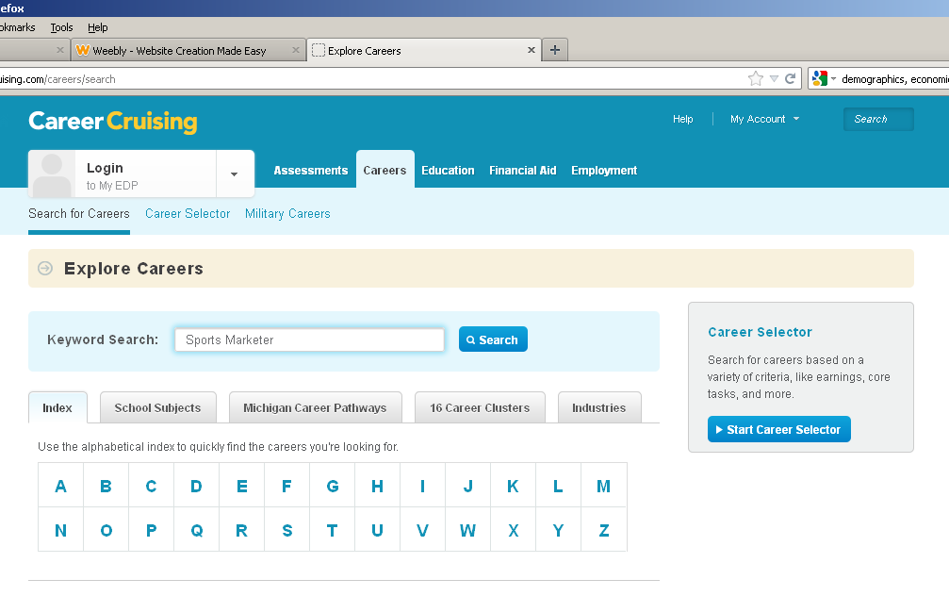
Click on the Career. On the following page and that will take you to the website you need to find all of your answers.

Click on the links that correlate to the topic. Example: Go to job description webpage to find job description.
