Strategic Marketing
Business Operations Paper
Topic
Develop a plan to rebrand an existing business or organization to add value to the brand. Using an existing business or organization of their choice, participants will research the business or organization and its current branding efforts.
Participants will develop a detailed plan to enhance or rebrand the organization. Efforts may include, but are not limited to, new logos, new mission statements, new signage, new digital media, new store layouts, and the like. The goal of the revisions should be to add value to the brand and the organization.
  - Whatever company or organization you choose must already exist

  - Whatever you do must be of value to the company you select.

The options you have to organize your paper are as follows:
    - Business Services
      - Human Resources, Information Technology, Personal & Contracted Business Services
      - Examples of such companies would include such things as
        - HR: Staffing agencies, Employee Relation Firms, etc..
          - http://www.inc.com/inc5000/list/industry/human-resources
        - IT: Computer Repair, Facebook, Adobe, Linked In, Google, Riot Games, etc…
          - http://en.wikipedia.org/wiki/List_of_the_largest_information_technology_companies
          - http://www.businessinsider.com/top-25-tech-companies-to-work-at-in-2013-2013-7?op=1
        - Personal & Contracted Services: Insurance Companies, Advertising Firms, Lawncare, Day Care, Pet Groomers, Personal Chef, Moving Company, etc
          - http://www.franchisehelp.com/industry/business-services-franchise

    - Buying & Merchandising
      - Retailers that provide business goods: Walmart, Target Home Depot, Best Buy, Whole foods, etc..
        - http://www.stores.org/2012/Top-100-Retailers
      - Wholesalers that provide business goods
        - Wholesalers are primarily in the Business-to-Business Industry
        - Examples includes Reyes Beverage Company & Silver Eagle Distributors, LP, etc..
        - http://groundreport.com/the-ten-types-of-wholesalers-understanding-their-functions-strategies-and-the-role-they-play-in-t/
        - http://business.gov.in/manage_business/wholesalers_retailers.php

    - Finance:
      - Banks: Wells Fargo, Chase, Bank of America, etc..
      - Credit Unions: Navy Federal, Teachers Federal Credit Union, Coastal Federal Credit Union
        - Video explaining difference http://www.youtube.com/watch?v=cawzTSVTP2M
      - Accounting Firms: Ernst & Young, KPMG, PricewaterhouseCoopers etc..
      - Investments:Franklin Tempelton, Fidelity, Edward Jones, ING, Vanguard
      - Financial Businesses: E*trade, Amerivest Advisors, etc..
        - http://www.efinancialcareers.com/companySearch/location-USA/initial-a.htm

    - Hospitality & Tourism
      - Hotels: Ritz-Carleton, Westin, Walt Disney Resorts, etc..
        - http://en.wikipedia.org/wiki/Category:Hotel_chains
      - Restaurants: PF Changs, McDonalds, Chick-Fil-A
        - http://en.wikipedia.org/wiki/List_of_restaurant_chains_in_the_United_States
      - Tourism-Related Businesses: Pink Jeep Tours, Alcatraz Media,
        - http://www.ranker.com/list/tourism-companies/reference

    - Sports & Entertainment Marketing
      - Businesses that conduct sporting &/or entertainment events:
        - Palace Entertainment, Walt Disney Company, DTE Concert Series; Charlotte Bobcats, UNC Sports, etc..
        - http://www.forbes.com/pictures/mli45ikdf/1-manchester-united-2/
        - http://www.vault.com/rankings-reviews/company-rankings/consumer-services/best-media-entertainment-companies.aspx

  - Develop a plan to rebrand an existing business or organization to add value to the brand.
    - Create a new logo , New Mission Statement, New Signage, New Digital Media, New Store Layouts, etc….

Questions due by end of hour:
- I have chosen to do my paper on :________________________________________________________

- The category I am competing in for Business Operations is ___________________________________

- I will be working Individually Partner:_________________________________________

- Write a brief synopsis of what you plan on doing to add value to the brand you have chosen. Be as specific as you can in terms of explaining what you will do and why there is a need for it. Attach this description to this paper.

- The type of person I could reach out to in order to help me better understand my industry is _______________________________________________________________________.

- I know someone who works in the industry I am doing my paper on & will have them proofread my paper for accuracy and thoroughness.
Yes No
- I know someone who works in a different industry that might be able to help others in class.
Yes No *If yes, list industry, organization, & job title of person.
___________________________________________________________________________________________
- List any other information will you need or questions do you have regarding the paper that is due.
________________________________________________________________________________________________________________________________________________________________________
Introduction of Paper is due Friday, September 6, 2013

The best advice I can give you is to pick a company you can work directly with. If you look at all the national winners; that is a key component to their success. The Introduction of your paper will be much stronger because you know the community and can effectively explain all facets of this section. If you choose a company that is not local it would be better for them to have a “home city” v. other.

Introduction
  - Description of the business or organization
    - Information to include in this section:
      - History of the Business (when and where it started)
      - Information on the Founder and Owner
      - Location or Locations & Background of company
      - Briefly introduce Mission Statement / Philosophy (Explained more in depth in I. c)
      - Target Market(s)
      - Form & Type of business: Service Business? Franchise? What industry are they in?
      - Overview of the Business’s Services / Products
      - Include any other information on what makes this business unique or special

  - Description of the community (economic, geographic, demographic, and socioeconomic factors)
    - Economic

    - Geographic

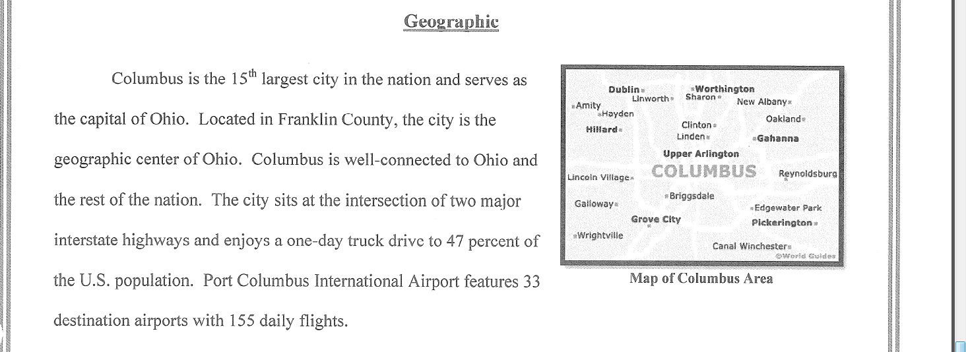
    - Demographic
Gender, Race, Age, Income, Marital Status, Education Level, Occupation

    - Socioeconomic
Religion, Birth Rate, Death Rate, Average size of family, average age at marriage,

  - Descriptions of the business or organizations mission, target market, and existing branding efforts
    - Be specific about what the mission statement is and how it is implemented in company activities, strategies, goals, etc…
      - List mission statement
        - Most mission statements are available online
        - If using a small, local company ask them
      - Explain what the mission statement means
      - What does the company do to show they are striving for the mission they are using

    - Clearly define the target market of this company and give supporting evidence as to why that market exists

      - Specifically breakdown the target market of this organization
      - At least 2 factors used to describe your market (athletic, males)
      - Can have a primary and a secondary market
      - All promotional strategies will be geared towards appealing to this audience

    - Detail current marketing and branding efforts of the company you have chosen.
      - This should be a very thorough analysis of all marketing aspects done within their brand.
        - Company Colors
        - Logo
        - Mascot/Trade Character
        - Employee Uniforms
        - Store Design
        - Storefront
        - Marketing Mix Strategies
        - Service Options
        - Sales Approach

