April Fools Day 2014: The Best of the Brand Hoaxes.

April 1, 2014 Written by Rebecca Cullers
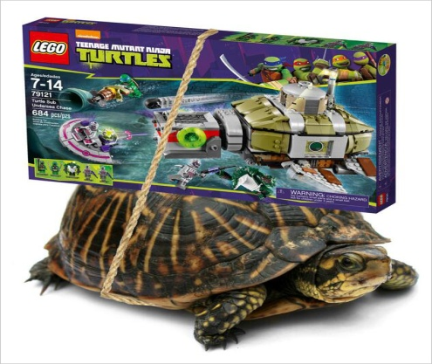
This year, all the usual brand suspects are joined by a host of tech companies and startups in trying to throw you for a loop—a near impossibility these days. And in an odd move, American Eagle Outfitters pranked us an entire week early.
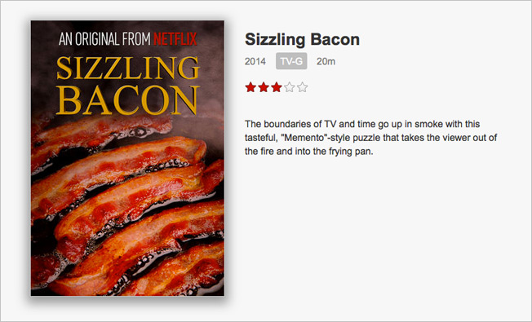

Lego: The toy brand is delivering its new Ninja Turtles set via live turtles.
Netflix: Watch Bacon sizzle with Netflix's new original series, Sizzling Bacon. If it's half as popular as Fireplace for your Home, they've got a winner.
Honda: The automaker creates the world's first DIY car.
Sam Adams: The brewer releases HeliYum, the world's first helium-carbonated beer.
House of Cards: The Netflix show gave everyone a sneak peak of season 3 with a script page on Facebook.
WestJet: The airline is converting to "metric time" to be even more Canadian.
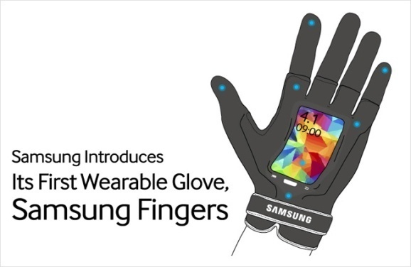
RedBox: The DVD rental company created Mood Match, which lets you auto-match your movie selection to your mood. Disappointed that it's fake? Get 50 cents off today with the code April Fools.
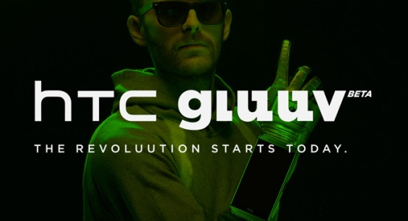

Samsung and HTC: Both brands have made fake wearable tech gloves. HTC won this battle.

CERN: The Large Hadron Collider is switching to exclusively using Comic Sans font and is adding a Justin Bieber selfie to its logo.
Google Chrome: The browser wants to translate everything to Emoiji. Turn it on for your browser, and it will work only for today.
Twitter: The Twitter helmet will allow you to tweet with a simple pecking head motion.
Tumblr: Tumblr has launched Tumblr pro, a new service that puts top hats on everything. Be sure to watch the amazing, inspiring video.
Microsoft: Clippy, the helpful paperclip, has returned to his reign of terror on Office.com.
Captain Morgan: Taco flavored Rum
Chili's: The restaurant chain has put everything you love about Chili's in an ice cream. Try Nacho Queso Crunch, Baby Back Chunk and Buffalo Brownie Sundae. Because there's a pregnant lady somewhere.
American Eagle Outfitters: Charging out of the gates last week, American Eagle announced American Beagle Outfitters, a new clothing line for dogs, complete with a dogumentary.
Cheetos: Spokescheetah Chester released his new fragrance, Cheeteau. They took it a step further by actually making a few bottles of the stuff, and sent one to AdFreak. It reeks, and not in a good way. In New York City today? Try it yourself on Madison Avenue between 59th and 61st Streets.
YouTube: The video site announces the absurd viral trends for the rest of the year.
Rosetta Stone: The language software company now lets you Learn to Speak Klingon. It's another product some people would actually buy. Plus, they got Worf himself, Michael Dorn, to star in the video.
Assignment:
Option A: (Individual)
Create an April Fool’s Prank Promotion that presents an outlandish idea from any company of your choosing. If you are struggling for ideas visit http://www.adweek.com/adfreak/april-fools-day-2014-best-brand-hoaxes-156671 for a list of examples that took place this year.
Prank Ad will be graded based on the following criteria. Each worth 5 points:
- Original Ad Created. All content presented is original.
- Headline is created that attracts viewers attention & makes them interested in what you have to say
- Illustration that attracts attention & encourages the viewer to be interested in what you have to offer
- A signature is included that supports the company being advertised
- Advertisement is fictional but realistic. Meaning the company/product you are promoting could develop the idea you have presented but as not and most likely never would.

- Advertisement is colorful, creative, & interesting to look at. An effective ad will increase interest and catch the viewer’s attention. It should be easy to understand and humorous for those that sees it.

Option B: (Can be completed in groups of 4 or less)
Create a commercial that presents a prank promotion. Video needs to be at least :30 second in length and should be uploaded to youtube or saved as a video file.
- Video needs to be school appropriate (5 points)
- At least one member from your group needs to be in the video created (5 points)
- Video needs to be saved as a separate file or uploaded to youtube for viewing. (5 points)
- Video needs to be entertaining to watch (class grade average out of 15 points)

