Nothing Bundt Cakes
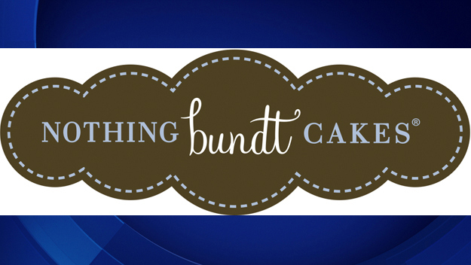

INTERNATIONAL BUSINESS PLAN EVENT
Nothing Bundt Cake Bakery

Ardrey Kell DECA
Ardrey Kell High School
10220 Ardrey Kell Road
Charlotte, North Carolina 28227
Olivia Murphy and Ali Morrisey
February 26, 2015
1

2

4

5

6

7

9

10

11

12
13

14

16

17

Table of Contents
- EXECUTIVE SUMMARY
- INTRODUCTION

- ANALYSIS OF THE INTERNATIONAL BUSINESS SITUATION
- Economic, political and legal analysis of the trading country
  - Describe the trading country’s economic system, economic information important to your proposed business/product/service, the level of foreign investment in that country

  - Describe the trading country’s governmental structure and stability, how the government controls trade and private business

  - Describe laws and/or governmental agencies that affect your business/product/service

- Trade area and cultural analysis
- Geographic and demographic information, important customs and traditions, other pertinent cultural information, competitive advantages and disadvantages of the proposed product and/or service

- Market segment analysis target market (age, income level, population estimate, other specific demographic and economic information) customer buying behavior related to the proposed product and or service

- Analysis of the potential location—importance and requirements of each trade document required by the U.S.A. and/or Canada and the country of choice

- PLANNED OPERATION OF THE PROPOSED BUSINESS/PRODUCT/SERVICE
- Proposed organization

- Proposed product/service
  - Details of the product(s)/service(s) to be offered; include potential suppliers, manufacturing plans, inventory policies, if applicable. If the business is a service business, appropriate information about plans to provide the service, including necessary supplies

  - How the product/supplies will be transported to/from the home country; costs, benefits, risks of the transportation method; documents needed to transport the product/supplies

- Proposed strategies
  - Proposed pricing policies, what currency will be used, costs, markups, markdowns, relation to competition, factors that could affect the price of the product

  - Proposed promotional program, promotional activity(ies), media availability, costs, one-year promotional plan outline

- PLANNED FINANCING
- Projected income statements for first year’s operation (sales, expenses, profit/loss)

- Projected balance sheet for the end of the first year

- A brief narrative description of the planned growth of the proposed business, including financial resources, needs and a brief three-year plan projection
D. Pictures of our product line
- BIBLIOGRAPHY

- EXECUTIVE SUMMARY

Nothing Bundt Cakes is a small bakery with several sizes and flavors of bundt cakes served readily at hand. The goal of Nothing Bundt Cakes is to create a cake that not only reminds you of home, but to open you to a new world. The opening of Nothing Bundt Cakes in Bristol, United Kingdom gives us great pleasure, as it will be our very first opening in a country other than America, home to hundreds of our bakeries.

Due to our extreme success within America, we have decided that it is time to expand our bakery internationally. We believe that there is a need for our bakery in Bristol, United Kingdom. Specifically, we are opening in a small area right next to Bristol University. The country’s high GDP rate, high standard of living, low tax rates for foreign investment, and low barriers for entrepreneurship, Bristol seems like the perfect place to go. Going international will be especially easy in the United Kingdom due to the fact that the majority of people who reside there speak fluent English.

The target market for our bakery will be females aged from eighteen through twenty-three who attend Bristol University and enjoy social settings and sweet treats. We will also have a secondary audience who will consist of people visiting our campus, who will either be parents and relatives visiting the college, or people who enjoy traveling in the Bristol area. Over twenty three thousand, five hundred girls can call Bristol University home. This is a huge number, and we are positive that we will be successful in our move.

Our limited partnership between the Nothing Bundt Cakes in Waxhaw, North Carolina will be very helpful in starting our business. Also, Nothing Bundt Cakes headquarters are going to pay for our first year of promotions for free. This is a huge deal in that college students will be hearing about our bakery quickly and frequently, which will help jump-start our business dramatically. When we first arrive in the United Kingdom, we will have $400,000 to start the business and $25,000 in liquid cash.

- INTRODUCTION
- Describe the type of business you are proposing to open
Nothing Bundt Cakes is a bakery that makes customized cakes for all occasions and specializes in bundt cake creations. We perceive it to be a great business opportunity to open in the United Kingdom because it is aimed at college students and tourists who enjoy dessert treats and flavors.
- Describe, in general, the types of products and/or services you plan to offer
Nothing Bundt Cake bakeries offer a wide assortment of homemade cake flavors and signature icing, in a variety of sizes to accommodate both large and small gatherings, such as eight inch cakes (thirty dollars), ten inch cakes (forty-five dollars), tiered cakes, and bundtlets (five dollars). Nothing Bundt Cakes is. Nothing Bundt Cakes also offers miscellaneous gifts such as wine and shot glasses, cozys, wine openers, and several other knick knacks.
- In what country/area of the world will you locate your business? (also city, area of city, etc?)
Nothing Bundt Cakes will be opening its business in Bristol, United Kingdom near the campus of Bristol University.
- Why do you think this is a smart business opportunity for this part of the world?
Opening in Bristol, United Kingdom would be a smart business move because it is very similar to America. They speak English, they are only five hours ahead of us, and there trading laws are very similar to ours. The University is at the heart of the city, it is easy to get to for both students and other residents. Due to the minimal distance between the highway (Motorway- M4 and M5) and the University. Bristol is one of the top thirty universities in the world and is one of the top five targeted universities by employers. We decided to open in the student union, directly on campus because it is the hot spot to go to when you are doing homework or wanting a quick bite to eat. Bristol is home to over twenty thousand students, thirteen percent of which are international.
- Who will be your target market for this business?
We believe Bristol University will bring in large amounts of revenue, because it achieves our primary target market of eighteen through twenty three year old females, which make up fifty-two percent of the population. We think females will love this home-away-from-home bakery and its products because it provides a warm environment that is friendly and tasty. “Our students always say how much they love the city of Bristol - from its friendly people and fantastic music scene to its vibrant harbourside, green spaces and buzzing centre. Best of all, Bristol is the perfect size, offering all the excitement of a big city packed into an area you can easily explore on foot or by bike.” (www.universityofbristol.com)
- Where will you find information on how to start up and run this business?
We will be communicating with the manager of Nothing Bundt Cakes, Jim Davis, to find out more information on opening this franchise. SAS cupcakes, another Charlotte based bakery is also a very good communication line to help us with the semantics of opening a bakery in another country due to their broad business line. Besides business’ that may be able to help us thrive in the United Kingdom, we have our parents, who all work in the marketing world. They are very knowledgeable about the financing, management, and promotion that will have to take place in order to reach our product potential. Internet sources such as cia.gov or gov.uk will give us the basic information about our country while other sources such as nothingbundtcakes.com will provide us with the necessary demographics and regulations as well as the types of cakes and information regarding their business and policies. Nothing Bundt Cakes franchising website offers the steps and qualifications we need in order to buy into the business. We will need one hundred and fifty thousand dollars in liquid capital, a combined six hundred thousand dollar net worth, and an initial four hundred thousand dollar investment. The investment includes the franchise fee, grand opening allocations, signage, equipment, initial inventory, and royalty. We will also complete the personal profile, speak in front of the franchising team, speak with current franchises, review the disclosure documents, ad visit Nothing Bundt Cakes headquarters.

- ANALYSIS OF THE INTERNATIONAL BUSINESS SITUATION

Economic, Political, and Legal Analysis of the Trading Country
  - Describe the trading country’s economic system, economic information important to your proposed business/product/service, the level of foreign investment in that country

The United Kingdom has a capitalist free market economy which gives us a realistic view of how their economy functions due to capitalism in the United States. They have a population of almost sixty-four million out of which thirty million one hundred fifty thousand are part of the workforce. Their labor force includes eighty point four percent services, eight-teen percent industry, and one point four percent agriculture. We know that we will have no trouble at all finding workers in the Bristol area because of the unlimited amount of college students next door that need a job in order to pay for their education at the University. The United Kingdom has a Gross Domestic Product of thirty-seven thousand and has many industries, including: energy, mining, manufacturing, and construction.
When people think of the United Kingdom, they most likely think of fish and chips or tea. The United Kingdom shares many different cultural norms that we as a business are going to need to accustom to. We have researched that people in the United Kingdom do not appreciate being embarrassed, which is why approaching them wouldn’t be the best way to go about advertising. They could be mistaken due to their accent which would result to embarrassment. Icebreakers usually include short chats about weather in the country. Relationships usually develop slowly due to Britain’s enjoyment of privacy. Some cultural taboos that we will come across will be greeting strangers with a kiss, spitting in public, hugging strangers, and intimate questions.
  - Describe the trading country’s governmental structure and stability, how the government controls trade and private business

  - Describe laws and/or governmental agencies that affect your business/product/service

Two main government agencies are the FCA, Financial Conduct Authority, and FPC, Financial Policy Committee. The FCA develops regulations for imports, exports, and selling of products. The FPC enforce the rules to make sure businesses follow them. Our main source for this information was www.gov.uk. There are several other departments with rules such as the Department of Business, Innovation, & Skills, Department of Communities and Local government, Department of Environmental, Food, and Rural areas, and Department of Work and Pensions. After reading through several laws the main one that stuck out was “Employment Rights.” This law states that every worker must have a written copy of their rights such as hours, pay rate, and sick days. There are no trade barriers that we could come across between the United Kingdom and United States. Our one import, cake mix, will have to be retested by the European Union to ensure it is safe to bring in to the country and sell to the people of Bristol.

Trade Area and Cultural Analysis
  - Geographic and demographic information, important customs and traditions, other pertinent cultural information, competitive advantages and disadvantages of the proposed product and/or service

In order to ship back and forth, licenses are needed for import and export of any goods, technology, artworks, plants and animals, medicines and chemicals. The exportation any products such as dairy goods are the responsibility of the Department for Environment. Imports of food are controlled and must agree with regulations such as food safety, labeling and additives. It is very important to have all the requirements for your paperwork when exporting or importing products. Things such as missing or inaccurate documents can increase risks, leading to delays and extra costs, or even prevent a deal from being completed. We must also have a commercial invoice, which is a bill for the goods from the seller to the buyer. These invoices are used by governments to determine the true value of goods when going through customs. The commercial import will control imports by specifying its form, content, number of copies, language to be used, etc. We will need an export packing list, which will list the seller, buyer, shipper, invoice number, date of shipment, mode of transport, carrier. It will show the quantity, description, type of package, quantity of packages, weight, and dimensions. Before shipping our supplies from Las Vegas to Bristol, will will send a pro forma invoice which will inform the goods to be sent, their value, and other key specifications. As a global center for international trade, the United Kingdom has a number of international airports. Major cities, such as London, have several airports as well as bus or train connections to local and regional transport networks.
Competitive advantages in the United Kingdom include the fact that it takes thirteen days to set up a business compared to the average thirty-two days, there are low tax rates for foreign investment, there are very few barriers for entrepreneurship, it is one of the most stable countries based on political environment, the United Kingdom has the highest GDP growth rate in all of Europe, the majority of the country speaks English, and there is a very high quality of living in the country. Competitive disadvantages would be that our currency is worth less in the United Kingdom. We also discovered their lack of reliable electricity. Due to the fact that we could not find many disadvantages of opening a business in this country, we are content with our decision in starting a business here. One obstacle we will come across is distribution channels from Las Vegas, Nevada to Bristol. We also will have to worry about the cost to ship the cake mix between the U.S. and U.K. It may be challenging to advertise and compete with other bakeries that are located on campus. A large difficulty with locating in the United Kingdom will be adapting to the habits and customs that have been set in place over long periods of time in this historical country. We will be changing our hours to align with college life, as well as the design and structure of our building to make it more of hangout place where students are able to socialize or study.
  - Market segment analysis target market (age, income level, population estimate, other specific demographic and economic information) customer buying behavior related to the proposed product and or service

Although there has been a dramatic increase in the amount of international students attending Bristol University, the majority of the students will be coming from Great Britain. Our target market consists of a primary and secondary buying group. Our main focus is going to be females aged from eighteen through twenty-three, that attend Bristol University and enjoy social settings and sweet treats. Our secondary audience will consist of people visiting our campus, such as parents and relatives that will stroll through on their way to visit their college students. These customers will most likely be from the middle to upper class due to the fact that Bristol is a quality university that includes a tuition of nine thousand euros in-state and fifteen thousand euros internationally.
The middle class attains an average household income of thirty seven thousand euros, with over half of this group having ten thousand euros in savings. The upper class has an average household income of fifty thousand euros to one hundred thousand euros (very wealthy). It will be a great benefit to our bakery to be located on campus so that we can target to all students living/attending classes there. Behavioral aspects of the target market will focus on customers that like to celebrate birthdays or by buying their friend a nice treat for a special occasion. A great benefit of having a ‘Nothing Bundt Cakes’ on campus in Bristol University would be having the opportunity to have a homemade bundt cake so far from home. College students will be able to use money that they have saved to buy themselves an enjoyable treat at any time. We have sample trays located at the front of the store to allow the customers to taste a certain flavor that appeals to them. We chose this town due to its high population of young adults. Our target market can easily be reached, it is accessible to students, and we have easy access to pick up out supplies!
  - Analysis of the potential location—importance and requirements of each trade document required by the U.S.A. and/or Canada and the country of choice

IV. PLANNED OPERATION OF THE PROPOSED BUSINESS/PRODUCT/SERVICE

A. Proposed Organization
As we open our store in Bristol, United Kingdom, we will be in a limited partnership. After much consideration, we decided making decisions with someone else who is experienced in Nothing Bundt Cakes as well as in the business world, would be our smartest move. By partnering with the original business owners of Nothing Bundt Cakes; we know our voice would be heard, that we would gain knowledge about entrepreneurship, and be able to more effectively operate our business. Due to the fact it is a partnership, an advantage we would maintain is that we cannot lose any more money than we invest. We will be partnering with the current owners, Jim and Tia Davis, the franchise managers of the original Nothing Bundt Cakes located in Waxhaw, North Carolina.
Our direct foreign investment will be a limited partnership, an advantage would be you do not have to pay both personal and business taxes, a limited partner's liability for the partnership's debt is limited to the amount of money or property that individual partner contributed to the partnership, and you can leave without dissolving the partnership. Some disadvantages are you are legally responsible for the actions of each of your business partners, the limited partner does not have much say in regular business matters or large decisions, and individual partners are not obligated to consult with other participants in certain business agreements.
Nothing Bundt Cakes in the United Kingdom will have a functional structure. An advantage of this model is that we can determine our specific needs and cater our marketing mix to our customer base. Although departments work independently, it will be most efficient for our business because we are the first ones to take Nothing Bundt Cakes out of the United States; therefore, we have to start from scratch with our research. We can determine our own target market accordingly, rather than mimicking what Nothing Bundt Cakes does in the United States. We will choose our own marketing; create our own prices based on the cost of supplies in the United Kingdom
Starting a business in the United Kingdom is very simple and straightforward. We will take the necessary steps, much like those required in the United States when we officially open our business. We have the ability to lead, yet follow a system, financial capability, a strong belief in the Nothing Bundt Cakes product, as well as business management.
For our store, we will need at least two greeters, a crafter, two bakers, and two frosters. Our store hours will be nine a.m. until ten p.m., our bakers will arrive around seven a.m. to start baking the cakes, the frosters will arrive at eight a.m. so the cakes have time to cool, and then they will be able to begin frosting promptly. The greeters and crafters will work normal shift hours. The greeters will stand in the front of the store and welcome customers. They need to be aware of the amount of cakes, boxes, and designs we offer. The crafter will put together our specialty cakes and prepare packages. The bakers will prepare the cakes and make the frosting from scratch every morning. The frosters will frost the cakes daily. Once applicants apply, they will go through a six-day training process, “Greeter Training Checklist,” provided by corporate. Employees will be paid, seven euros and fifty cents above minimum wage.

B. Proposed Product/Service
  - Details of the product(s)/service(s) to be offered; include potential suppliers, manufacturing plans, inventory policies, if applicable. If the business is a service business, appropriate information about plans to provide the service, including necessary supplies

“At Nothing Bundt Cakes our goal is to create a cake that not only reminds you of home, but also opens you to a new world. In addition, while that is no easy request, the handcrafted recipes of our founders, Dena Tripp and Debbie Shwetz, are more than up to the task. Each recipe only uses the purest ingredients, fresh eggs, real butter, and real cream cheese, all to bring you bundt cake perfection. Enjoy.” This is the mission statement of Nothing Bundt cakes, written by its owners. We will be shipping our cake mix from Las Vegas, Nevada on a continuous basis. Because cake mix stays fresh for at least four to five months, we will be ordering new cake mix every four months. We will have the cake mix shipped from Las Vegas, where it will be sent directly to Bristol, United Kingdom. The advantages of this distribution method will be that we won’t have to worry about tracking the mix through many different distribution channels. The disadvantages will be that it will be costly to ship the mix over five thousand miles. This will cost us about $600 a year, but the costs of sending the cake mix to Bristol will be paid for by the owners of the company. This is the main ingredient we will need, but other ingredients such as eggs, butter, and cream cheese will be bought locally where it will be convenient to buy any ingredients as soon as we need them. Not having these products shipped will allow us to have fresh bundt cakes. A problem that we might face is finding a large grocery store that will be able to sell their goods to us regularly and in large amounts. We are going to need items such as eggs, milk, and butter to add to our cake mix so that we are able to make fresh bundt cakes whenever we need to. These are some of the only natural resources we need in the United Kingdom because we will be bringing most of our supplies over when we first leave the United States to start our business. These items include but are not limited; couches, light fixtures, tables, countertop, display counter, computer, refrigerator, oven, rugs, fireplace, cash register, packaging for products, printer, chairs, and utensils.
  - How the product/supplies will be transported to/from the home country; costs, benefits, risks of the transportation method; documents needed to transport the product/supplies

The supplies that we are sending to Bristol, United Kingdom will be sent from plane every four months. The plane will send our products to Bristol Airport, which is approximately an hour from Bristol University. We will have one of our paid employees go to pick up our cake mix from the airport and drive back. This will be fast and efficient for us as a business due to our busy hours. It will probably be a little pricy to ship the goods from Las Vegas, Nevada to Bristol, United Kingdom, but it is fully necessary to ensure the freshness of our cakes. The electronic export information document says that we must transport goods that are priced over $2,000. We will need a pro forma invoice before we send the final commercial invoice, which is the main document used by customs for control. Details must include buyer, seller, description of goods, quantity, purchase price or fair market value, terms of the sale, and date.

C. Proposed Strategies
  - Proposed pricing policies, what currency will be used, costs, markups, markdowns, relation to competition, factors that could affect the price of the product

When we arrive in Bristol, United Kingdom, we will go to the bank and trade our dollars for pounds so that we can have the correct mode of currency. For every American dollar, we will receive point sixty-four of a pound. We will be marking our products up by twenty percent. This will give us the extra money we need to run in a foreign country.
  - Proposed promotional program, promotional activity(ies), media availability, costs, one-year promotional plan outline
Due to the great benefit of being located in a college town, to get our company running, we will be handing out free bundtlet coupons that will expire quickly so that people will be interested in visiting our store and trying our products. This of course will be monitored by the school and we will be sure to get approval before we go about doing this. These promotion methods are used in Nothing Bundt Cake is worldwide, and the company pays for it to get us started (refer to figure one on page 16). The country’s tax rate is similar to the United States taxes, so we will already be accustomed to the extra fee that comes with buying a product.

V PLANNED FINANCING

Figure 1

1. Initial Franchise Fee: $25,000
2. Extension Fee: $0 to $10,000
- Under the Franchise Agreement, you are required to purchase or lease an Approved Location for the Bakery meeting the company’s standards and specifications within 90 days of the Effective Date of the Franchise Agreement. In the event you do not meet the 90-day site selection deadline, the franchisor will charge you a fee of $3,500 on the 90th day.
3. Utility Deposits and Lease Security Deposits: $6,500 to $8,500
- Each Bakery location will occupy approximately 1,600 to 1,800 square feet of space. Bakery locations for Nothing Bundt Cakes Bakeries typically are on busy retail streets, in strip shopping centers, and other venues in retail, commercial, and suburban areas.
- The security deposit is typically for one month.
- Depending on your local jurisdiction, water tap, sewer tap, and other similar fees may be required. These fees are not included in the estimate and you should determine if you will have to pay these fees and the amount of the fees before you purchase the franchise.
4. Bakery Improvements: $120,000 to $150,000
- Bakery improvement costs include a modified, aboveground grease trap, electrical, carpentry and similar work, and contractor’s fees.
- You may not act as your own general contractor but must use a licensed, bonded contractor with food/restaurant build-out experience.
5. Architect – Design: $7,000 to $8,500
- You must use an approved architect. Included in these costs are a design site visit, code research and space layout review (front and back of the Bakery), and construction drawings.
6. Fixtures and Equipment – Front of Bakery: $26,000 to $33,000
- This includes exterior signage, interior signage such as promotional/seasonal advertising package, wall hangings/pictures, and point of purchase signage. Also included are lighting, phone system, furnishings, millwork and woodwork, music system, tax, shipping, and opening print materials orders. You must have shredder capabilities.

7. Fixtures and Equipment – Back of Bakery: $80,000 to $90,000
- This includes all large kitchen equipment, shipping, kitchen small wares, office supplies, the office and constructing computer, and all-in-one fax copier. Any used equipment you wish to purchase must be approved by the franchisor.
8. Initial Inventory: $26,000 to $26,200
- This estimated amount includes cake design accessories, dry cake mix ingredients, and other supplies that are distributed through the franchisor’s affiliate, Shipp Distribution. The estimate also includes the opening retail order for the front of the Bakery that may be distributed through Shipp Distribution; the initial cost of your food order from local suppliers for flavorings, packaging, miscellaneous bakery list items, and linen.
9. Point of Sale System: $15,000 to $23,000
- This includes a DSL high speed internet connection, the point of sale system with the recommended 2 point of sale stations and all associated cables, monitors, printers, and security router, excluding taxes.
- This estimate also includes the $250 set-up fee associated with linking your Bakery to the company’s E-Commerce Program for online ordering and delivery, which is payable to the company’s designated supplier.
10. Insurance: $800 to $1,000
- These amounts reflect potential monthly costs. Insurance costs may be substantially higher in areas of the country subject to natural disasters, like hurricanes.
11. Business License and Permits: $1,500 to $2,500
- These are general estimates for permits and local and state governments may require licensing that.
12. Professional Fees: $3,000 to $10,000
- The estimate assumes that you will employ an attorney to help you negotiate your lease for the Bakery premises. In addition, you may choose to employ an attorney, accountant, and other consultants to help you evaluate the franchise offering and your establishment of a new business, and in obtaining all required permits and licenses to establish and operate the Bakery. In addition, you may also form a corporation or other entity to operate the business.

13. Grand Opening Marketing: $5,000 to $7,000
- You must pay the franchisor $5,000 when you sign the Franchise Agreement and it will spend this amount on a grand opening program for initial marketing, advertising, and promotions in your Territory.
- Your Grand Opening must be held within 30 to 45 days after your Bakery opens. The minimum amount to be spent for your Grand Opening will be $5,000, but you may be required to spend up to $7,000.
- This estimate does not cover the cost of samples you may purchase from other Bakeries to promote the opening of your Bakery.
14. Training Expenses: $4,000 to $6,000
- You will incur expenses associated with the training program. For this training program, the franchisor provides instructors and instructional materials at no charge for up to two people, but you must pay for transportation, lodging, food, and wages (if you send any employees) for your trainees.
15. Additional Funds – 3 Months: $20,000 to $40,000
- This item estimates working capital needed to supplement your first 3 months of operation (other than the items identified separately in the table).
- This estimate includes the cost of in-store music, POS System monthly fees, and some system maintenance costs. These expenses include payroll costs but not any draw or salary for you.
- The franchisor assumes that you can use your existing vehicle in connection with Bakery deliveries.
16. Total Estimated Initial Investment: $339,800 to $440,700

Twelve-Inch Bundt Cake with decorations bought at Nothing Bundt Cakes
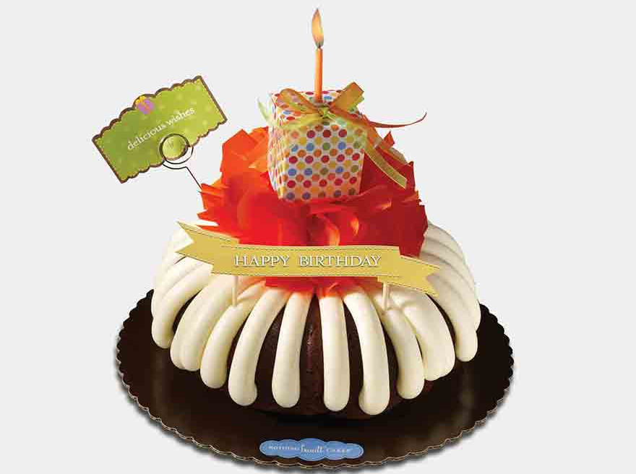
Eight Inch Bundt Cake with simple decorations also bought at Nothing Bundt Cakes
Bundtlet with Flag
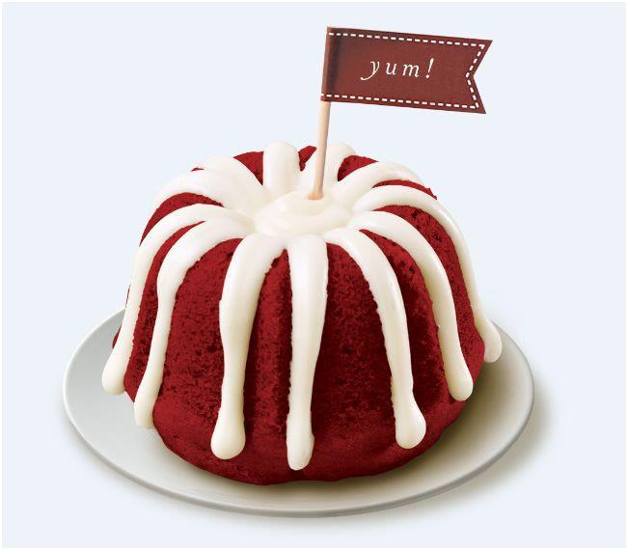
Bundtinis
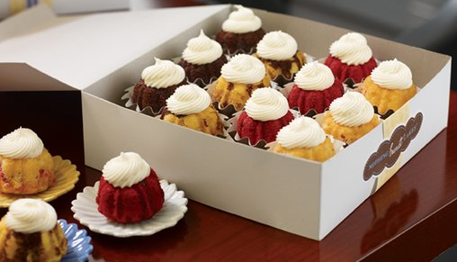

Works Cited

"All about Bristol." - Visit Bristol. N.p., 2010. Web. 02 Feb. 2015. <http://visitbristol.co.uk/about-bristol/all-about-bristol>.
Bristol University. Bristol University, 2015. Web. 02 Feb. 2015. <http://bristol.ac.uk/>.
Central Intelligence Agency. Central Intelligence Agency, 2015. Web. 02 Feb. 2015. <https://www.cia.gov/library/publications/the-world-factbook/geos/uk.html>.
Chatter, Franchise. "Franchise Costs 2013." FranchiseChatter. N.p., 20 July 2013. Web. 02 Feb. 2015. <http://www.franchisechatter.com/2013/07/20/franchise-costs-2013-detailed-estimates-of-nothing-bundt-cakes-franchise-costs-2013-fdd/>.
Davoren, Julie. "Functional Structure Organization Strength & Weakness." Small Business. Demand Media, n.d. Web. 02 Feb. 2015. <http://smallbusiness.chron.com/functional-structure-organization-strength-weakness-60111.html>.
"Love You to Pieces." Home of the Most Delicious Bundt Cakes Ever. N.p., n.d. Web. 02 Feb. 2015. <http://www.nothingbundtcakes.com/>.
"Nothing+bundt+cakes - Google Search." Nothing+bundt+cakes - Google Search. N.p., 2013. Web. 02 Feb. 2015. <https://www.google.com/search?q=nothing%2Bbundt%2Bcakes&biw=1239&bih=656&source=lnms&tbm=isch&sa=X&ei=2SbQVLnQDJKHgwTGg4T4BA&sqi=2&ved=0CAcQ_AUoAg#imgdii=_&imgrc=kKDWIPoDQGP94M%253A%3BAoqnUKLmfRF7LM%3Bhttp%253A%252F%252Fwww.nothingbundtcakes.com%252F_resources%252Fdyn%252Ffiles%252F1228967zdd959403%252F_fn%252Flogo.png%3Bhttp%253A%252F%252Fwww.nothingbundtcakes.com%252F%3B288%3B108>.
"Partnership Advantages and DisadvantagesCOLOR="#000066"" Partnership Advantages and Disadvantages. N.p., 2009. Web. 02 Feb. 2015. <http://www.how-to-start-a-business-guide.com/partnership-advantages.html>.
Pirraglia, William. "Advantages & Disadvantages of Limited Liability Partnerships." Business & Entrepreneurship. Demand Media, n.d. Web. 02 Feb. 2015. <http://yourbusiness.azcentral.com/advantages-disadvantages-limited-liability-partnerships-2255.html>.
"United Kingdom Customs." British Customs: Regulations, Export-Import Procedures by Customs of United Kingdom. N.p., 2015. Web. 02 Feb. 2015. <https://united-kingdom.visahq.com/customs/>.
"Welcome to GOV.UK." Welcome to GOV.UK. N.p., 2015. Web. 02 Feb. 2015. <https://www.gov.uk/>.
"Welcome to the U.S. Commercial Service UK – Providing Export Assistance to the UK." United Kingdom Home. N.p., 2015. Web. 02 Feb. 2015. <http://export.gov/unitedkingdom/>.

