II. Analysis of the international business situation

- Economic, political and legal analysis of the trading country

  - Describe the trading country’s economic system, economic information important to your
proposed business/ product/ service, the level of foreign investment in that country
Japan has a Free Market economy. This means that businesses in Japan can trade freely and competitively with other companies. The advantages of this is anyone can bring a business in and have equal opportunity to succeed, but they also have just as much chance to fail miserably. Japan doesn’t have as strong a hold on patents and business ideas as say, the US does, but one would be able to safely assume that if they brought a business in, given a market for it, it would be most likely to succeed without many complications.
An Economic Impactor of Japan that might wash out the above stated chances of success, pardoning any pun, would be the example of the 2011 tsunami that devastated most of Japan. Being a coastal island type country, Japan is susceptible to many disasters of the water. This of course includes Hurricanes, Sea-storms and yes, even Tsunamis. To build a business in Japan, one would have to make sure that the majority of critical business information is available in the case of one of these disasters. Japan’s GDP is 4601.46 while the US has a GDP of 17419.
Although Japan has a low FDI, it has been increasing. Japan and the US have high trading relationships. Japan's fourth highest export is to the US while their fourth largest import is from the USA. The FDI if Japan is located in the $1.75 trillion as of now. In 2013, the levels were at $2.3 billion even though this was an increase of earlier levels. Seoul, China and South Korea have generated talks about possible FTA that could lead to include Japan. China agreed with US to work in trade with Japan by the year end.
  - Describe the trading country’s governmental structure and stability, how the government
controls trade and private business
Japan has a parliamentary system of government called a constitutional monarchy, very similar to Canada and Britain. but unlike the US, the people of japan do not elect the president directly. Members of the government called the diet members elect a prime minister from among themselves. the Prime minister then creates his cabinet of ministers of state to lead the country. The current PM of Japan is Shinzō Abe. The PM runs in 4 year terms, but he or she is not limited to the amount of years he or she can run. Japan’s constitution was written in 1947. The constitution was written upon 3 ideals: sovereignty of the people, respect for the fundamental human rights, and the renunciation of war. the constitution breaks the government into 3 section, much like the government of the United States: the legislative, the executive, and the judiciary, in japan these “branches” are called the diet, the cabinet and the courts, respectively. Japan’s government is not very corrupt. It comes out to be that Japan racks 15 in the least corrupt countries in the world. however, there is a tradition called amakudari where retired government officials are assigned to top positions within Japanese companies. However, their assignment is often limited to financial, construction, transportation and pharmaceutical industries. some key Japanese anti-corruption legislation includes the Penal Code, which does not permit officials to receive facilitation payments, and the Unfair Competition Prevention Act, which limits gifts larger than 5000 yen, to be registered and disclosed. Japan participates in an enormous amounts of international organization including, but not limited to ADB, AfDB, APEC, Arctic Council, ARF, ASEAN, Australia Group, BIS, CD, CE, and CERN. Japan has a very high political globalization. for the past 15 years, it has kept its index above 85%. with an 82% free trade rate, Japan has been very free with their trade. With the US beating Japan by only 2 percent.

  - Describe laws and/or government agencies that affect your business / product / service:
Many agencies may hinder business in Japan. for example, the ministry of the Environment may limit our business on what and how we can dispose our waste form the manufacturing process. the Ministry of Health, Labor, and Welfare might lay wages floors for our business, very similar to minimum wages in the US. Japan has minimum wages set up by regions, because it costs different to live on one island vs another. Like the US, Japan has 40-hour work weeks (8-hour days) and overtime must be paid the employer. this may limit our attempt to lower the worker’s wage to increase our profit.
Japan and the US have high trading relationships. Japans fourth highest export is to the US while their fourth largest import is from the USA. Currently Japan’s GDP is at about 4601 billion USD. Their rate grows and falls at a steady rate which is good for business. Their import data varies depending on classification of item. Being a manufactured good we fall under the classification of their major imports. Japan imports globally over 54k Euros of manufactured goods based off of the 2014 imports list. While their list of imports has decreased, their list of exports has increased to roughly the same as imports with their balance being only slightly red, according to the EU annual data list for 2014. The JFTC PDF file labels their imports as rising 6% to 85.9 trillion yen. The value of the yen-dollar exchange rate has decreased by 8.4% leaving the value of one yen to the equivalent of 0.0084 dollars. Only 10% of their trade falls under the manufacturing goods label while the majority lies under mineral fuels. That leaves it to the fifth highest import although the direct investment of Japan in the US is mostly through wholesale trade and manufacturing sectors. Japan allows the following in rules of labor:
- Maternity leave of a female employee, and for 30 days afterward.
- Hospitalization of an employee following job-related illness or injury for 30 days
- Maximum full-time working hours is 8 hours a day
- 6 to 8 hrs of work equals 45 min break
- 8 hrs of work equals hour break
- Work over 8 hours, one needs to be paid overtime
- After 6 months of work employee are allowed 10 days of annual leave
- No discrimination based on gender

B. Trade area and cultural analysis
      - Geographic and demographic information, important customs and traditions, other
pertinent cultural information, competitive advantages and disadvantages of the
proposed product and/or service.
An environmental hazard of Japan that might wash out chances of business success would be, pardoning any pun, the example of the 2011 tsunami that devastated most of Japan. Being a coastal island type country, Japan is susceptible to many disasters of the water. This of course includes Hurricanes, Sea-storms and yes, even Tsunamis. To build a business in Japan, one would have to make sure that the majority of critical business information is available in the case of one of these disasters. Also to be noted is the fact that Japan ships a lot of exports in cargo ships. There are many dastardly issues on can have out at sea. All issues regarding the condition of objects on the ship at the starting point (whether the objects in question are considered hazardous) are brought up by the international Safety Of Life At Sea treaty (SOLAS) as well as the International Maritime Dangerous Goods code (IMDG). This covers all packaging, labeling and shipping of hazardous goods. Our product would need to pass this before shipping.
The largest group in Japan is 25 - 54-year-old females with men close behind. The median age is 47.9 for females, 45.2 for males, which averages out to 46.5 for both. Infant mortality rate is 2.08, birth rate is 7.93, and population growth rate is -0.16%. They have a 3 main ethnic groups which are as follows, Japanese (98.5%), Koreans (0.5%) and Chinese (0.4%), with the rest of the population falling under another category (0.6%). Education averages about 15 years of school. 16.1% of the population is beneath the poverty line as of 2013 compared with the 15.1% of US as of 2010 (percentages may be inaccurate to the current year).
Religions of Japan are as follows:
- Shinto (79.2%), is known as “The way of the Gods”. They believe that spirits are rooted in everything. Humans are good, spirits contain evil.
- Buddhism (66.8%) believe in Karma, rebirth and The Noble Path of Man.
- Christianity (1.5%) is the belief in God, the Holy Bible and the ascent to Heaven after death
- Other (7.1%) includes the possibility of any religion other than the three above.
The main language of Japan is indeed Japanese. The Japanese value the separation of public expression and private thoughts as well as respect towards elders. Meeting basics include a dress code that is best described by the phrase ‘It’s better to be overdressed than underdressed’. When in doubt, dress formally for any meeting you may have in Japan since casual is only for certain occasions. Japanese are sticklers for proper greetings. It’s usually best to bow a greeting bow (15 degrees). Of course, if it’s your boss, it’s better just to do a respect bow (45 degrees). Some of the more nonverbal points to recognize are those such as not making eye contact since it is considered rude in Japan. Another rude gesture would be to point directly at a person. It’s politer to gesture in the person’s direction with your palm facing upwards. In Japan, giving gifts related to the numbers four or nine are considered unlucky. This is because the words for “four” and “nine” in Japanese can sound like the words for “death” and “suffering” as well. Even hospitals avoid using the number four on their rooms. When giving a gift to someone, it’s common to do so with your hands on both sides of the gift and your arms extended. If you are introducing or even just addressing business partners and acquaintances, it is polite to do so by their family name, rather than given name. People in Japan generally don’t make it a habit to wear shoes indoors. They instead change into slippers. It’s rude to sit with the soles of your feet pointing at others; instead you should sit on your knees.
Hofstede’s Dimensions
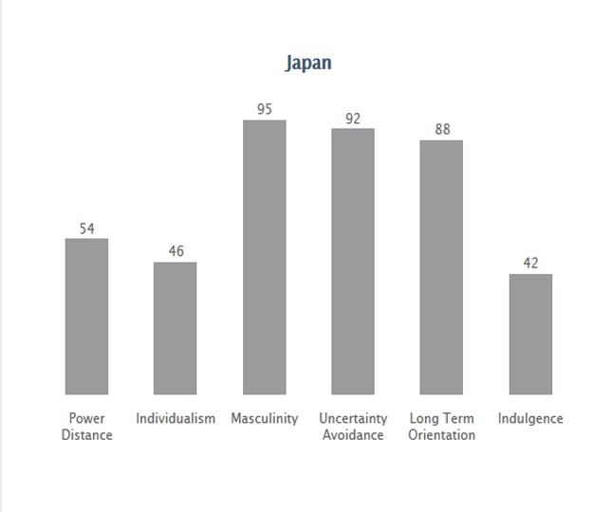
Japan values collectivism over individualism and is a high context country.

      - Market segment analysis target market (age, income level, population estimate, other
specific demographic and economic information) customer buying behavior related to the
proposed product and or service.

      - Analysis of the potential location- importance and requirements of each trade documents
required by the U.S.A. and/or Canada and the country of choice.

Japan is the best location for our business, because it is ranked 34 in the world for ease of doing business. Japan is ranked 14 in the terms of getting electricity, and 48 in registering property. Japan is ranked number 2 in resolving insolvency. Japan is a large island, very close to a continent. This make transporting good very easy. We can ship goods to its many ports and harbors around the island. We can also transport goods to russia or South Korea and then ship the goods to Japan. The climate in Japan is generally temperate. It shows 4 seasons: Winter, where the temperature rarely drops below 32
To transport in Japan we need a Commercial Invoice. A Commercial Invoice includes:
- Complete name and address information
- Phone numbers
- Terms of Sale
- Reason for export
- A complete description of the item
- Harmonized Tariff Codes, if known
- Country of origin for each commodity
- Number of units, unit value, and total value of each item
- Number of packages and total weight
- Shipper's signature and date

The purpose of the CO is to authenticate the country of origin of the merchandise being shipped. Japan generally provides strong intellectual property rights (IPR) protection and enforcement. They also signed the Anti-Counterfeiting Trade Agreement (ACTA) in 2011. There is very little in the way of barriers between the US and Japan in regards to our product, an eco-friendly commodity although there are unfavourable odds for US products in Japanese ocean trade deals.

